Phoenix Business and Workforce Development Board
Meeting Minutes
September 12, 2019 ~ 8:30 AM

The meeting of the Phoenix Business and Workforce Development Board was held on September 12, 2019, located at the Phoenix Business and Workforce Development Center, 302 N. 1st Ave., 6th Floor, Phoenix, AZ 85003.

Board Members Present:

Audrey Bohanan (Chairwoman) Jim Cahill
Kaaren-Lyn Graves Travis Hardin
Dean Van Kirk Susan Ciardullo
Jenna Kohl Daniel Barajas
Ali Gamero-Hernandez Jan Davis
Janice Mrkonjic Derek Anderson
Nick Bielinski Bethany Woodard
Fred Ingersoll Brandon Ramsey
Melissa Trujillo Michelle Jameson
Steven Cramer Delbert Hawk

Board Members Absent:

Nick DePorter
Michael Hale (Vice Chair)

Jesus Love

City of Phoenix Staff:
LaSetta Hogans (Executive Director)  Christina Edwards (Board Liaison)  Silvia Valadez Barba  Kweilin Waller  Stan Flowers | James Montoya  Mark Carr  Sandra Enriquez  Amy Corriveau  Tricia Quiroz
Chris Mackay  Patti Kirkland  Amanda Morrietta  Kerri Barnes  Hank Marshall | Dana Mosley  Lisa Kilgore  Teresa Riza  Laura Whitehead  Nichole Ayoola
Public Attendees:
Michael Burchett April Osborn
Karen Nelson-Hunter Shayne Abrahams
Kimberly Smith Dustin Panoff
Stacey Van Emst

- Call to Order
Phoenix Business and Workforce Development (PBWD) Board Chair, Audrey Bohanan, called the September 12, 2019 PBWD Board Meeting to order at 8:30 a.m. Roll call was completed and a quorum of 18 members were present, including in person and on the phone.

2. PBWDB Chair Update
PBWD Board Chair, Audrey Bohanan, stated she would like PBWD Board members to figure out at way to make ARIZONA@WORK part of their lives as they go about their day-to-day work activities in the community.

Chair Bohanan stated we need to align the Board’s efforts with Mayor Gallego’s priorities for economic development. Where are the skills gaps? What businesses are coming into Phoenix? How do we keep the businesses that we have? We want to become an attractive place for businesses to come and provide a talent pool that meets their needs for businesses to stay in Phoenix. These conversations will be ongoing throughout the year and feedback will be provided to the Board.

During the previous month the Workforce Arizona Council was working on the State Plan and some PBWD Board members have participated in those discussions and activities. Chair Bohanan encouraged Board members who have been engaged in the community to share their experiences with the group.

PBWDB member Susan Ciardullo has been serving on the Training EXPO committee, an annual, state-wide training conference hosted by the Arizona Private School Association. Monthly meetings have occurred with workforce system partners and training providers to prepare for the event on Nov. 1, 2019.

PBWDB member Steve Cramer has been continually involved with the Advanced Business Services (ABS) sector meetings. Anyone who is looking for support for a contact center environment is encouraged to attend the ABS meetings.

PBWDB member Kaaren-Lyn Graves shared that every chance she gets she shares information about the ARIZONA@WORK programs and services.

PBWDB member Melissa Trujillo was recently asked to be on the Board and is very passionate about learning more about the services available through ARIZONA@WORK City of Phoenix.

PBWDB member Daniel Barajas works for Maricopa Community Colleges and has many opportunities when working with employers throughout the valley to interject information about ARIZONA@WORK. Mr. Barajas is a part of the Arizona Department of Education State Planning workgroup and is helping to develop their State Plan.

PBWDB member Brandon Ramsey has been working to learn about all the ARIZONA@WORK programs and services, as he is a new member to the Board. Mr. Ramsey works for Microsoft and is extremely active in the workforce community and is looking for businesses our One-Stop Operators can partner with.

PBWDB member Ali Gamero-Hernandez works for Title III Employment Services and is a Business Engagement Committee member. Ms. Hernandez is constantly talking about ARIZONA@WORK with businesses in the state. Ms. Hernandez is continually sharing best practices around the state and is heavily involved with workforce as a mandated core partner.

PBWDB member Janice Mrkonjic works for Maricopa Corporate College and recognized Rob Stenson and Patti O’Brian for presenting WIOA programs and services information at the recent SHRM conference on Aug. 29th. The local SHRM chapter will be replaying some of that information at an upcoming event in the Valley.

PBWDB member Nick Bielinski continues to spread the word about ARIZONA@WORK services and has the ARIZONA@WORK logo on his email signature at his employer, TEKSystems. Mr. Beilinski attends several events with businesses and continually speaks about the programs and services available through ARIZONA@WORK.

PBWDB member Michelle Jameson works for U.S. Vets, a veteran focused agency. A veteran’s conference is coming up and Ms. Jameson will be on a panel and will have an opportunity to talk about ARIZONA@WORK.

PBWDB member Fred Ingersoll, Senior Apprenticeship Program Manager for Katerra Construction, is reaching out to organizations locally and across the nation about job opportunities. Katerra’s goal is to have 25% of their labor force be women and 50% be veterans.

PBWDB member Delbert Hawk, President of IBEW Local Union 640, has recently returned to the Board and hasn’t had a chance to talk about ARIZONA@WORK yet.

PBWDB member Jim Cahill, President of the Bricklayers Local Union 3, is so new to the Board that he hasn’t had a chance to promote anything.

PBWDB member Jenna Kohl stated her focus has been to participate in the webinars and meetings that LaSetta has provided information on and to continue learning as much as she can about ARIZONA@WORK.

PBWDB member Travis Hardin, from Wells Fargo, stated their company recently launched their ninth rendition of a financial literacy program and he specifically mentioned ARIZONA@WORK during the launch. Mr. Hardin received several questions from event participants on how their business can get involved with ARIZONA@WORK.

PBWDB member Dean Van Kirk, Training Director for Arizona Pipe Trades Apprenticeship, stated they have seen an upswing in referrals from ARIZONA@WORK.

PBWDB member Derek Anderson, from Banner Health, stated he is excited to continue marketing ARIZONA@WORK services and looks for opportunities for businesses to engage in our programs.

Chair Bohanan thanked the members for their efforts and encouraged them to call on each other to build relationships. Chair Bohanan stated we will have another Mix & Mingle event at the November PBWDB meeting and welcomed members to join.

3. Approval of July 11, 2019 Meeting Minutes
A motion to approve the July 11, 2019 Meeting Minutes, was made by PBWD Board Member Susan Ciardullo, and seconded by PBWD Board Member Travis Hardin.

Approved: Derek Anderson, Daniel Barajas, Nick Bielinski, Audrey Bohanan, Jim Cahill, Steven Cramer, Jan Davis, Delbert Hawk, Ali Gamero-Hernandez, Kaaren-Lyn Graves, Fred Ingersoll, Michelle Jameson, Jenna Kohl, Janice Mrkonjic, Brandon Ramsey, Melissa Trujillo, Dean VanKirk and Bethany Woodard

Opposed: None

Motion passed unanimously

4. Consent Items
The following Consent Items were presented for approval:
- hive@central June and July Reports

- One-Stop Operator Monthly Reports for June and July

- ARIZONA@WORK City of Phoenix Eligible Training Provider List – Programs Added

A motion to approve items A-C was made by PBWD Board Member Travis Hardin, and seconded by PBWD Board Member, Kaaren-Lyn Graves.

Approved: Derek Anderson, Daniel Barajas, Nick Bielinski, Audrey Bohanan, Jim Cahill, Susan Ciardullo, Steven Cramer, Jan Davis, Travis Hardin, Delbert Hawk, Ali Gamero-Hernandez, Kaaren-Lyn Graves, Fred Ingersoll, Michelle Jameson, Jenna Kohl, Janice Mrkonjic, Brandon Ramsey, Melissa Trujillo, Dean VanKirk and Bethany Woodard.

Opposed: None

Motion passed unanimously

5. Open Meeting Law (OML) Presentation
Teresa Riza, City of Phoenix City Clerk’s Office Supervisor, gave an overview of Open Meeting Law requirements to the PBWD Board members. The purpose of OML is to ensure that the public is involved in meeting discussions, that all decisions of the governing body are made in public, that the public have access to meeting information and that the public has an opportunity to participate in meetings.

6. PBWD Board Committee Updates
The following reports were submitted by the PBWDB Committee Chairs for review and discussion.

CIC:
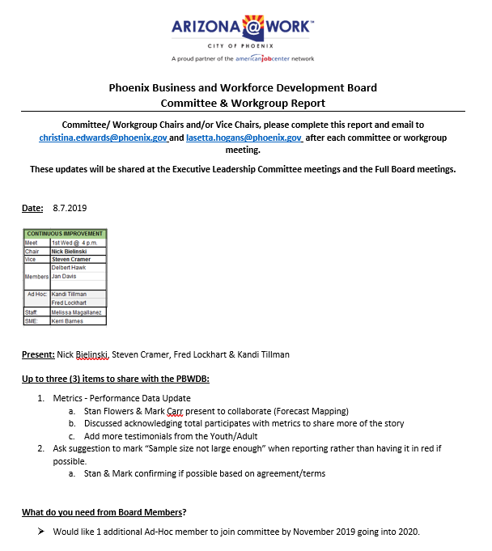

BEC:
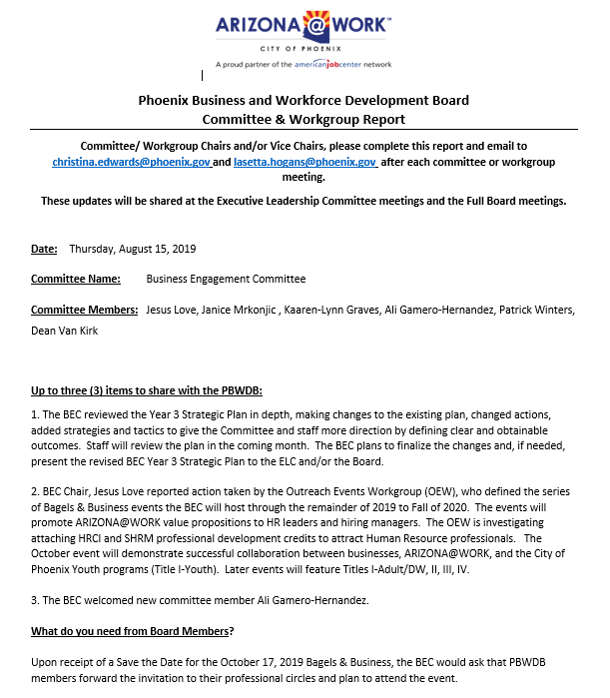

AYWC:
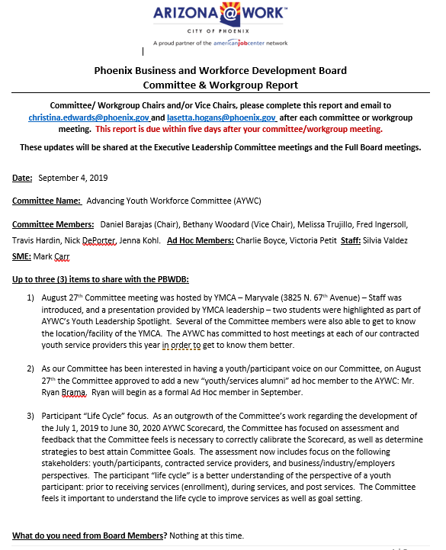

SDC:
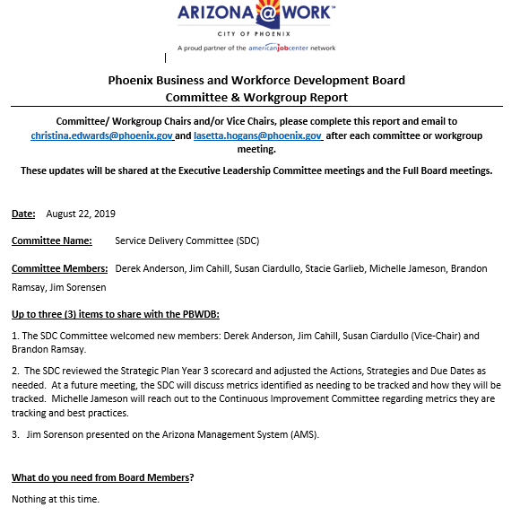
7. WIOA Budget Update
Deputy Human Services Director, Nichole Ayoola, reviewed the WIOA budget and expenditures with the PBWDB. Ms. Ayoola shared the budget to actual expenditures from July 2018 to June 2019 and the Fiscal Year 19/20 budget to actuals in July 2020. Ms. Ayoola broke down allocations for fiscal year 18/19 and fiscal year 19/20 for Board members to review. Lastly, Ms. Ayoola shared the allocations by program year for fiscal years 18/19 and 19/20.

8. Family Centered Employment
Deputy Human Services Director, Kweilin Waller, and Amy Corriveau presented information to the Board about the Family Centered Employment Initiative. In 2017, NAWB and Innovate+Educate partnered to pilot with 3 local workforce boards to advance a two-generation (2GEN) or Family Centered approach to workforce development with the support of the W. K. Kellogg Foundation. With a focus on advancing new pathways to employment for parents and families with children while providing linkages between early childhood development and employment, leading to economic advancement.

And in 2019, NAWB and Innovate+Educate expanded to incorporate more workforce development boards and launched the Family Centered Community of Practice (FCE CoP) to support workforce development boards interested in integrating family-centered approaches in their workforce development services and local communities. Phoenix, along with 11 other workforce development boards to join the 3 pilot sites in a Community of Practice.

As part of the COP, each workforce board identified ways to incorporate family-centered employment strategies that fit their local communities to create a more wholistic approach to serving parents and families.

The initiative focuses on advancing new pathways to employment for parents and families with young children with an emphasis on creating opportunities for and addressing needs of both children and their parents together to improve family outcomes.

There are 5 Key Components of the 2GEN approach:
1) Postsecondary Education and Employment Pathways;
2) Early Childhood Education and Development;
3) Economic Assets;
4) Health and Well-Being; and
5) Social Capital.

PBWD Board opportunities and next steps include:
- Consider including family centered employment in the new board strategic plan.
- Identify family centered employment funding opportunities.
- Create a family centered employment road map for community organizations, schools and other agencies wanting to develop strategies around workforce development.

9. MCWDB Regional & Sustainability Goal Workgroup Presentation
This presentation was not given and the presenter from the Maricopa County Workforce Development Board was not present at the meeting.

10. Matters for Future Discussion
- Present a comprehensive scorecard, including all committees, to the Board at the November meeting
- Include an Economic Development presentation at the next Board meeting that talks about what businesses are coming into Phoenix and how the Board assist in business attraction and retention.
- Encourage presenters that come to the Board meetings to include factual data or numbers that drive the ask from the Board
- Provide an industry sector partnership update at the November or January meeting.
- Include a PBWDB member “highlight” segment in future Board meetings that give members an opportunity to showcase their professional careers.
- Discuss what involvement the PBWDB has in Maricopa County’s Strategic Plan and present at a future meeting.

11. Call to The Public
None

12. Adjournment
A motion to adjourn the meeting was made at 10:07a.m. by PBWD Board Member Jan Davis seconded by PBWD Board Member Jim Cahill.

All were in favor and the meeting adjourned at 10:07a.m.

