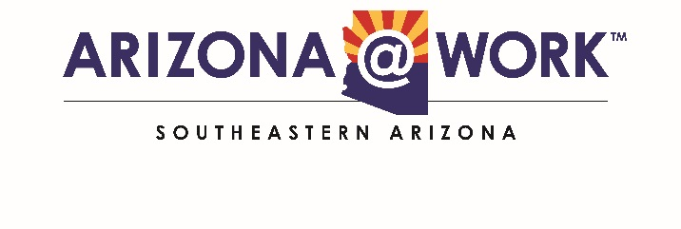
NOTICE AND AGENDA OF PUBLIC MEETING OF THE
SOUTHEASTERN ARIZONA WORKFORCE DEVELOPMENT BOARD (WDB)

Pursuant to A.R.S. § 38.431.02, notice is hereby given to the members of the Southeastern Arizona WDB and to the general public that the Southeastern Arizona WDB will hold a regular meeting open to the public on:

Thursday, March 19, 2020
2:30 P.M.
Executive Board Meeting
Center for Academic Success (CAS)
Administration Building-Conference Room
900 Carmelita Drive
Sierra Vista, Arizona 85635

AGENDA

A. Call to Order - Ron Curtis

B. Roll Call - Doris Tolbert

“If such a conflict does arise, I will declare that conflict before the board and

refrain from discussing and voting on matters in which I have conflict.”

C. Welcome Board Members:

D. Discussion Items:

- Develop leadership for the Board of Directors
- Recruiting Board Members
- The Annual Board Retreat
- Discussion on the future of ARIZONA@WORK Workforce Development Board

E. Next Meeting Date: Thursday, March 19, 2020 at 10:00 A.M.
Arizona Electric Power Cooperation
1000 Arizona 80
Benson, Arizona 85602
F. Adjourn

A copy of the agenda and background material provided to board members (with the exception of material relating to possible executive sessions) is available for public inspection at 900 Carmelita Drive, Sierra Vista, Arizona.

ARIZONA@WORK is an Equal Opportunity employer/program.

Auxiliary aids and services are available upon request to individuals with disabilities
Please call (520) 439-3541 (48 hours in advance) to make arrangement.

Funded by WIOA federal dollars serving Adults, Youth, and Dislocated Workers

