**Phoenix Business and Workforce Development Board**

**Meeting Minutes**

**September 10, 2020 ~ 8:30 a.m.**

**VIRTUAL MEETING**

**Board Members Present:**

Audrey Bohanan (Chairwoman) Michael Hale (Vice Chair)

Melissa Trujillo Travis Hardin

Steven Cramer Brandon Ramsey

Jenna Kohl Michelle Jameson

Edward Abramowitz Jan Davis

Latasha Causey Erick Garcia

Nick Bielinski Yolanda Bejarano

Daniel Barajas Kaaren-Lyn Graves

Nick DePorter Susan Ciardullo

James Frolov Jesus Love

Brenda Schmidt Bethany Woodard

**Board Members Absent:**

Dean Van Kirk

Fabian Sandez

**City of Phoenix Staff:** **Public Attendees:**

|  |  |
| --- | --- |
| LaSetta Hogans (Executive Director)  Christina Edwards (Board Liaison)  Kweilin Waller  Stan Flowers | Michael Burchett  Stacey Van Emst |
| Rob Stenson |  |
|  |  |

1. **Call to Order**

Phoenix Business and Workforce Development (PBWD) Board Chair, Audrey Bohanan, called the September 10, 2020 PBWD Board Meeting to order at 8:33 a.m. Roll call was completed and a quorum of 22 members were present virtually.

**2. Approval of** **July 9, 2020 PBWDB** **Meeting Minutes**

**A motion to approve the July 9, 2020 PBWDB** **Meeting Minutes**, was made by PBWDB Board Member, Travis Hardin, and seconded by PBWD Board Vice Chair, Michael Hale.

**Approved:** Edward Abramowitz, Daniel Barajas, Yolanda Bejarano, Nick Bielinski, Audrey Bohanan, Susan Ciardullo, Steven Cramer, Latasha Causey, Jan Davis, Nick DePorter, James Frolov, Erick Garcia, Kaaren-Lyn Graves, Michael Hale, Travis Hardin, Michelle Jameson, Jenna Kohl, Jesus Love, Brandon Ramsey, Brenda Schmidt, Melissa Trujillo, and Bethany Woodard.

**Opposed***:* None

**Motion passed unanimously**

**3. Consent Items**

The following Consent Item was presented for approval:

* One-Stop Operator July Report

**A motion to approve the consent item** was made by PBWD Board Member Jan Davis and seconded by PBWD Board Member Daniel Barajas.

**Approved:** Edward Abramowitz, Daniel Barajas, Yolanda Bejarano, Nick Bielinski, Audrey Bohanan, Susan Ciardullo, Steven Cramer, Latasha Causey, Jan Davis, Nick DePorter, James Frolov, Erick Garcia, Kaaren-Lyn Graves, Michael Hale, Travis Hardin, Michelle Jameson, Jenna Kohl, Jesus Love, Brandon Ramsey, Brenda Schmidt, Melissa Trujillo, and Bethany Woodard.

**Opposed***:* None

**Motion passed unanimously**

**4. ARIZONA@WORK Job Centers Update**

One-Stop Operations Manager, Stacey Van Emst, shared a presentation with the Board around the delivery of services since the onset of COVID-19. While keeping Centers for Disease Control guidelines at the forefront, the job center teams worked to create a plan for assisting customers that come into the job centers while moving the delivery of program services to an online platform.

At the beginning of the health pandemic, two, daily conference calls were coordinated with the job center partner agencies, one-stop operator staff and WIOA program leadership to address changes in services and customer issues around the application of unemployment insurance (UI) benefits. Through this communication, the teams were able to address staff concerns, ensure appropriate staffing levels, and exchange information with DES Title III staff regarding the continuous changes for UI benefit eligibility.

The graph below was presented by the One-Stop Operator and shows the year over year difference in the volume of customers visiting all three City of Phoenix comprehensive job centers. The graph shows an unprecedented up tick of customers visiting the centers from April 2020 through July 2020 and at its busiest point, seeing close to 4,000 customers in one week.

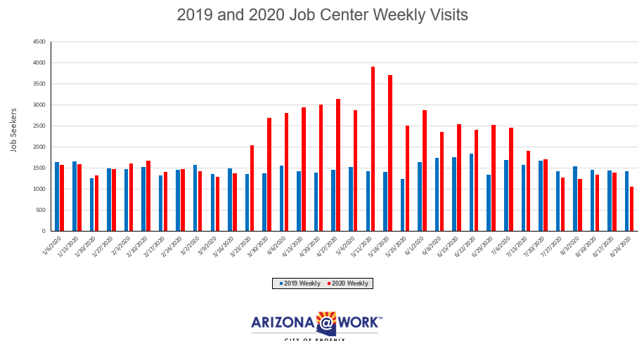

Stacey shared that security measures and the cleaning of the job centers was increased to include day porters at each job center location. The day porters cleaned high-traffic surfaces and door handles throughout the day and cleaned computer stations after each customer use. Customers experiencing symptoms of COVID-19 were asked to leave the job center and connect with job center staff virtually for assistance.

Between five and six additional staff members were added to the Welcome Team during this timeframe to assist with customer flow and assistance in the resource rooms (computer labs). Everyone worked well as a team to ensure staff and customers were safe, while providing much-needed services to the community.

At this time, many customers are not looking for work and the team is identifying ways to engage with customers and get them thinking about training or education, as well as job placement services.

PBWDB Vice Chair, Michael Hale, asked Stacey what her biggest fear is. Stacey indicated that she wants to connect more with the community on getting the word out about the services ARIZONA@WORK City of Phoenix can provide. Additionally, Stacey would like to create an environment at the job center that is welcoming to all, including mid-level professionals.

PBWDB Chair, Audrey Bohanan, thanked Stacey and her team for their ability to pivot during a difficult time while still provided services to those who are most in need. The PBWD Board greatly appreciates the work they have done.

**5. WIOA Budget Update**

PBWD Board Fiscal Agent, Nichole Ayoola, presented WIOA allocation, budget and expenditure information for Program Year 2019 and Program Year 2020. Additionally, the Fiscal Agent presented information on the Program Year 2019 carryover funds.

**Program Year 2019**



**Program Year 2019 Carryover**



**Program Year 2020**



**6. WIOA Performance Metrics Negotiation Outcomes PY20 & PY21**

PBWDB Vice Chair, Michael Hale, stated he had the honor of representing the Board during the WIOA Performance Negotiations process for program years 2020 and 2021. In preparation and support of the negotiations meeting with the Arizona Department of Economic Security (ADES), Board and Program Operator staff prepared information on best and worst-case scenarios for each WIOA performance measure.

The PBWDB’s overall approach, using a bandwidth and stretch goals for each measure, was unique and none of the other local areas used this approach. ADES had to negotiate with the U.S. Department of Labor on the statewide goals and therefore, some measures, such as Measurable Skills Gain, were not allowed to be negotiated during this process. Additionally, the goals set for program year 2020 will be the same for program year 2021. The ADES indicated they would support the Board any way they can in reaching the goals that were negotiated through technical assistance and training as needed.

The ADES used the Statistical Adjustment Model (SAM), including participant demographics and economic conditions, when determining the goals. Impacts due to COVID-19 will automatically adjust using the SAM at the end of each program year. This means the goals will automatically go up or down based on the SAM factors. Some goals were negotiated at a higher percentage than what the Board was originally comfortable with, however, this was to be expected as part of the negotiation process. Vice Chair Hale continued to walk the Board members through each goal as shown below.

|  |  |  |  |
| --- | --- | --- | --- |
| **WIOA Performance Metrics Goals PY20 & PY21** | **Adults** | **Dislocated Worker** | **Youth (14-24)** |
| **Employed 2nd quarter after exit**  (GED/HSE or training for Youth) | **67.2 %** | **75.3%** | **71.3%** |
| 90% of target | 60.5% | 67.8% | 64.2% |
| **Employed 4th quarter after exit**  (GED/HSD or training for Youth) | **65.2%** | **72.3%** | **67%** |
| 90% of target | 58.7% | 65.1% | 60.3% |
| **Median Wage** | **$5,850.00** | **$8,646.00** | **$4,500.00** |
| 90% of target | $5,265.00 | $7,781.40 | $4,050.00 |
| **Credential** | **71.1%** | **70%** | **44%** |
| 90% of target | 64% | 63% | 39.6% |
| **Measurable Skills Gains** | **59.2%** | **50%** | **52.8%** |
| 90% of target | 53.3% | 45% | 47.5% |

PBWDB Member, Susan Ciardullo, asked if actual numbers can be shared, along with the percentages, moving forward so that the Board can see how many individuals are being served. PBWDB Executive Director, LaSetta Hogans, said that actual numbers of individuals can be shared along with the percentages to the Program Excellence Committee (PEC).

Executive Director Hogans shared that because the City of Phoenix drives the majority of the WIOA performance for the state, future WIOA funding allocations need to match the expected performance of our local area. A point of discussion with ADES for future WIOA funding allocations will be around the expected, and delivered, performance of the City of Phoenix local workforce development area and that we will be requesting additional funding to match the State’s expectation of performance.

Vice Chair Hale closed the discussion reminding the Board that we act with integrity and make ethical decisions as a Board to complete the work that is expected of them.

**7. Work Plan Updates**

PBWDB Executive Director, LaSetta Hogans, review Work Plan items with the Board.

* Executive Director Hogans shared that the first item on the Work Plan is the **Performance Negotiations** and thanked Michael and Audrey for all of their efforts on this item. This item is now complete.
* The **Local Plan** was submitted to ADES for review and they have provided feedback and needed adjustments. The revised Local Plan was sent back to ADES for final review. We are awaiting their response.
* The **MOU/IFA** draft was submitted on September 4, 2020. This was only a draft. We are waiting on feedback from ADES. After the feedback is received, meetings will be held with core partners to finalize outstanding items. Then the MOU/IFA will be submitted for final approval to the PBWDB and ADES, after partner signatures have been obtained.
* The **Shared Local Governance Agreement (SLGA)** will need to be updated by the end of calendar year 2020. The Program Operator agreement will need to be updated as well. PBWDB Members Nick Bielinski and Brandon Ramsey are champions on this item. Updates to the SLGA are next on the list to be completed.
* **Job Center Certifications** are completed, and it was a wonderful success. The Job Center Certification Workgroup is working to finalize Part II of the certification process and their final meeting will be on Sept. 29. The certification tools will be forwarded to ADES once completed and approved by the PBWDB.
* **Board Recertification** is due by October 31, 2020 and we are on target to having all of the Work Plan items completed for recertification.
* **Policies** will continue to be updated throughout the year and brought to the Board for approval.

**8. Committee Reports**

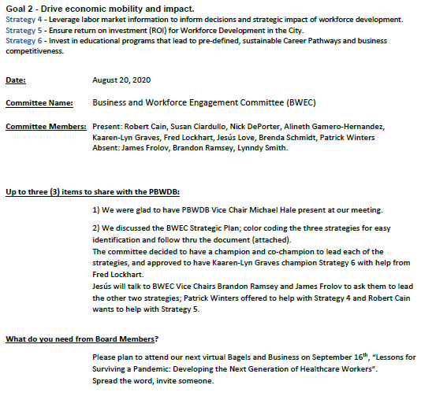

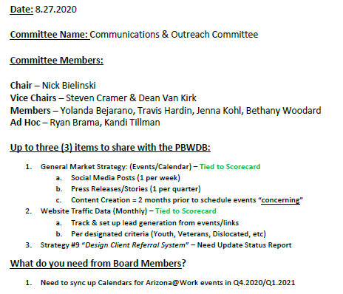

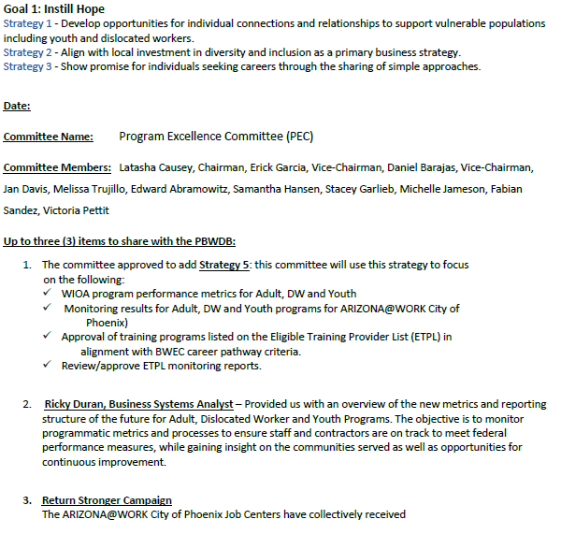

**9. Matters for Future Discussion**

* PBWDB Member, Nick DePorter, offered to share Linkedin workforce reports with the Board
* Health check with PBWDB members and how they are doing in today’s environment
* Veterans issues in the City-evection prevention funding for Veterans
* Continue success stories at future PBWDB meetings
* Workforce initiatives update from Rodrigo, formerly at the Mayor’s Office
* Current employment trends due to COVID – bandwidth/internet connectivity issues in the City

**10. Call to The Public**

None

**13. Adjournment**

**A motion to adjourn the meeting was made at 10:11 a.m.** by PBWD Board Member, Jesus Love, and seconded by PBWD Board Member, Travis Hardin.

**Approved:** Edward Abramowitz, Daniel Barajas, Yolanda Bejarano, Nick Bielinski, Audrey Bohanan, Susan Ciardullo, Steven Cramer, Latasha Causey, Jan Davis, Nick DePorter, James Frolov, Erick Garcia, Kaaren-Lyn Graves, Michael Hale, Travis Hardin, Michelle Jameson, Jenna Kohl, Jesus Love, Brandon Ramsey, Brenda Schmidt, Melissa Trujillo, and Bethany Woodard.

**Opposed***:* None

**All were in favor and the meeting adjourned at 10:11 a.m.**