Phoenix Business and Workforce Development Board
Meeting Minutes
July 9, 2020 ~ 8:30 a.m.

VIRTUAL MEETING

Board Members Present:

Audrey Bohanan (Chairwoman) Michael Hale (Vice Chair)
Melissa Trujillo Travis Hardin
Steven Cramer Brandon Ramsey
Jenna Kohl Michelle Jameson
Edward Abramowitz Jan Davis
Latasha Causey Erick Garcia
Nick Bielinski Yolanda Bejarano
Dean Van Kirk Kaaren-Lyn Graves
Nick DePorter Susan Ciardullo
James Frolov Fabian Sandez

Board Members Absent:

Daniel Barajas
Bethany Woodard

Jesus Love
Brenda Schmidt

City of Phoenix Staff:
LaSetta Hogans (Executive Director)  Christina Edwards (Board Liaison)  Kweilin Waller  Stan Flowers | Mark Carr  Eddie Barajos  David Chavez  Sandra Enriquez
Chris Mackay  Rob Stenson | Laura Whitehead
Public Attendees:
Michael Burchett Tracey Regenold
Stacey Van Emst Sheila Murphy

- Call to Order
Phoenix Business and Workforce Development (PBWD) Board Chair, Audrey Bohanan, called the July 9, 2020 PBWD Board Meeting to order at 8:50 a.m. Roll call was completed and a quorum of 20 members were present on the phone.

2. Approval of May 14, 2020 PBWDB Meeting Minutes
- A motion to approve the May 14, 2020 PBWDB Meeting Minutes, was made by PBWDB Vice Chair, Michael Hale, and seconded by PBWD Board Member Latasha Causey.

Approved: Edward Abramowitz, Yolanda Bejarano, Nick Bielinski, Audrey Bohanan, Susan Ciardullo, Steven Cramer, Latasha Causey, Jan Davis, Nick DePorter, James Frolov, Erick Garcia, Kaaren-Lyn Graves, Michael Hale, Travis Hardin, Michelle Jameson, Jenna Kohl, Brandon Ramsey, Fabian Sandez, Melissa Trujillo, and Dean Van Kirk.

Opposed: None

Motion passed unanimously

- A motion to approve the May 26, 2020 Advancing Youth Workforce Committee Meeting Minutes, was made by PBWD Board Member, Travis Hardin, and seconded by PBWD Board Member Nick DePorter.

Approved: Edward Abramowitz, Yolanda Bejarano, Nick Bielinski, Audrey Bohanan, Susan Ciardullo, Steven Cramer, Latasha Causey, Jan Davis, Nick DePorter, James Frolov, Erick Garcia, Kaaren-Lyn Graves, Michael Hale, Travis Hardin, Michelle Jameson, Jenna Kohl, Brandon Ramsey, Fabian Sandez, Melissa Trujillo, and Dean Van Kirk.

Opposed: None

Motion passed unanimously

- A motion to approve the May 12, 2020 Continuous Improvement Committee Meeting Minutes, was made by PBWD Board Member, Nick Bielinski, and seconded by PBWD Board Member Steven Cramer.

Approved: Edward Abramowitz, Yolanda Bejarano, Nick Bielinski, Audrey Bohanan, Susan Ciardullo, Steven Cramer, Latasha Causey, Jan Davis, Nick DePorter, James Frolov, Erick Garcia, Kaaren-Lyn Graves, Michael Hale, Travis Hardin, Michelle Jameson, Jenna Kohl, Brandon Ramsey, Fabian Sandez, Melissa Trujillo, and Dean Van Kirk.

Opposed: None

Motion passed unanimously
3. Consent Items
The following Consent Items were presented for approval:

- Section 100.108 WIOA Allowable Costs Policy
- Section 900.906 Job Center Certification Policy
A motion to approve consent items was made by PBWD Board Member Nick DePorter and seconded by PBWD Board Member Travis Hardin.

Approved: Edward Abramowitz, Yolanda Bejarano, Nick Bielinski, Audrey Bohanan, Susan Ciardullo, Steven Cramer, Latasha Causey, Jan Davis, Nick DePorter, James Frolov, Erick Garcia, Kaaren-Lyn Graves, Michael Hale, Travis Hardin, Michelle Jameson, Jenna Kohl, Brandon Ramsey, Fabian Sandez, Melissa Trujillo, and Dean Van Kirk.

Opposed: None

Motion passed unanimously

4. City of Phoenix Recovery Efforts
City of Phoenix Community and Economic Development Director, Christine Mackay, provided an update on the economy and efforts the City is conducting to assist businesses in Phoenix.

Director Mackay shared that the City has contacted more than 16,000 businesses since March of 2020 to connect them with available resources. A Phoenix Business Hotline has been established to answer questions businesses have during this health pandemic. An online resource page was developed at Phoenix.gov/Resources that provides connections to various other business resources. Additionally, staff have assisted companies with their loan applications for EIDL and PPP and created “How To” videos explaining the application process in detail.

Several Phoenix Business Resilience Grants are open and include:

- Small Business
- Restaurant Restart
- Micro
- Water

The total amount of grant funds currently available is $21 million and with these grants the City expects to assist over 22,000 businesses in Phoenix.

Director Mackay shared that in today’s business climate in Phoenix more than sixty percent of jobs are in the advanced industries market. Pre-Great Recession numbers show that only forty-three percent of jobs were in the advanced industries sector. This positions Phoenix to quickly recover from COVID job losses. Even with the pandemic, the City of Phoenix Community and Economic Development Department brought more than 10,000 new base industry jobs to the City.

Director Mackay closed the presentation by saying the City is resilient and well-positioned to recover from COVID-related stress to the economy and projects the Board will see a resurgence of new companies offering family-sustaining jobs in the near future.

PBWDB Vice Chair, Michael Hale, wanted to know if a contingency plan has been put together, due to COVID? A plan to rebuild our image and bring information to the public in a timely manner. Director Mackay stated that our status in the country has changed significantly in the last few months and Arizona has been featured on a national level for the number of COVID cases we are seeing. Director Mackay stated that the contingency plan is something the department will continue to work on and will let the Board know if there is a way for them to support the plan. Director Mackay indicated she will work on having a contingency plan ready to share, after working with PBWDB Executive Director, LaSetta Hogans, and should have it to the Board within the next week.

PBWDB Member Susan Ciardullo inquired about the healthcare needs in the City and if efforts are still being made to fill healthcare jobs. Director Mackay shared that the City and department are still focused on the healthcare and bioscience industries and it is still a number one push for economic development.

5. Strengthening Working Families Initiative (SWFI) Presentation
The PBWD Board’s Program Operator, Deputy Director Kweilin Waller, Human Services Department, gave a presentation on the status of the Strengthening Working Families Initiative (SWFI) grant. Deputy Director Waller stated they are happy to come back to the Board today to share some good news regarding the SWFI grant, and then turned the presentation over to David Chavez, SWFI Program Supervisor.

Mr. Chavez reviewed the SWFI performance outcomes from the previous SWFI presentation to the Board in July of 2019. At that time, forty-four percent of the targets had been met. SWFI services were paused and a workgroup was formed to explore ways to revamp the SWFI program in order to meet the grant objectives. Staff were cross-trained and SWFI career navigators were placed at all three job center locations. A one-year extension was requested from the US Department of Labor until June 30, 2021 to allow for more time to meet performance expectations and realign some of the grant objectives.
As of March 2020, significant improvement towards grant outcomes has been achieved as shown below:

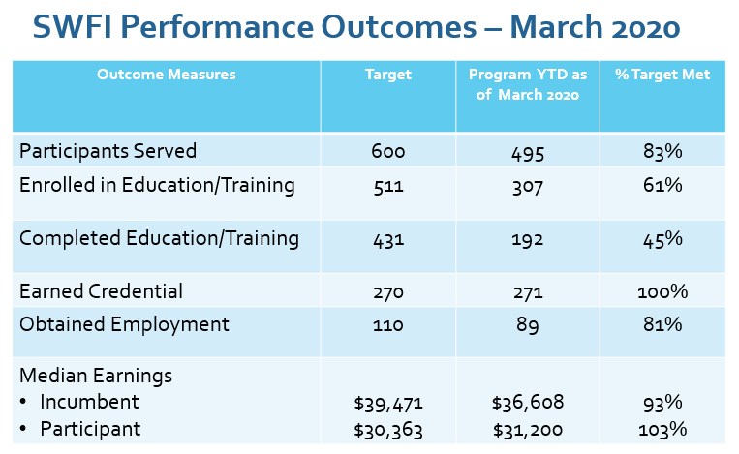

The percent of changes between July 2019 and March 2020 are shown in the comparison table below:

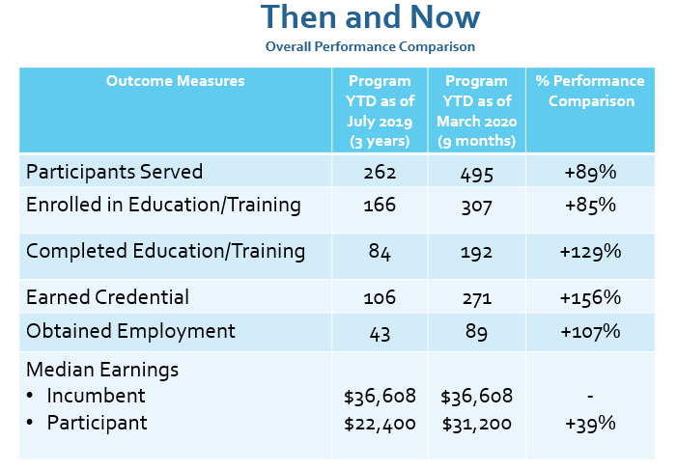

6. Business and Workforce Engagement Committee (BWEC) Update - Bagels & Business Event Recap
PBWD Board Member, Kaaren-Lyn Graves, gave on update on behalf of the BWEC.

- The BEC, in collaboration with Google, hosted the first virtual Bagels & Business event on Wednesday June 17th from 9:00AM to 10:00AM. PBWDB Chair Audrey Bohanan delivered welcoming remarks while Rob Stenson was the emcee. This was a very engaging presentation featuring four panelists representing: Google (#GrowWithGoogle) ASU Learning Enterprises, Maricopa Community Colleges IT/Cybersecurity Industry Sector, and SHRM of Greater Phoenix. The program focused on improving existing and preparing future career pathways into IT specifically highlighting the benefits of Google’s IT certification programs. Audience details: 73 individuals registered and 48 attended. BEC Staff will send a “Thank You” email to attendees, and a “We Missed You” email to registered individuals who did not attend. These emails will include collateral from the presentation (as a follow up) with an ask to “Save the Date” for our next Bagels & Business event. A shout out of appreciation to Chair Audrey Bohanan, Vice Chair Michael Hale and Board Members who attended our June 17 Bagels & Business event.

- To build momentum, we intentionally scheduled the next Business and Bagels virtual event for Wednesday September 16th, 2020 at from 9:00AM to 10:00AM. September is the National Workforce Development Month dedicated to recognizing the contributions of workforce professionals and highlight events and initiatives which support job seekers and employers.

- We discussed the proposed new committee structure as we look forward to the reorganization of this committee and welcome all new members.

What do you need from Board Members?

Please save the date for our September 16th 9:00AM Bagels & Business event. We would like to see our entire, if not the majority, of our Board Members in attendance online and we ask that each of you invite employers and others within your professional circles of influence to join us! Our goal is to have >100 registrations and actively engaged webinar participants. Watch for an event flyer to help you help us promote the event. Thank you!

7. PBWDB Work Plan Update
PBWDB Executive Director, LaSetta Hogans, shared the Work Plan is available to view in BoardBookit and briefly reviewed each item on the plan.
- Executive Director Hogans shared that the first item on the Work Plan is the Performance Negotiations with a deliverable date of July 15, 2020.
- The expected Performance Metrics will go into our Local Plan, which is due to DES by July 15, 2020.
- The MOU/IFA updates are in process. Several meetings have taken place with partners already along with meetings that still need to be scheduled regarding shared costs.
- The Shared Local Governance Agreement (SLGA) will need to be updated by the end of calendar year 2020. Updates to the SLGA have not started just yet.
- Job Center Certifications are on the agenda today and we will be looking for volunteers for the Job Center Certification Workgroup.
- Board Recertification is due by October 31, 2020 and we are on target to having all of the Work Plan items completed for recertification.
- Policies will continue to be updated throughout the year and brought to the Board for approval.

8. WIOA Expected Performance Measures PY20 & PY21
PBWDB Executive Director, LaSetta Hogans, reviewed the performance measures excel worksheet, detailing all WIOA performance metrics for Adult, Dislocated Worker and Youth programs. Executive Director Hogans reviewed each WIOA performance measure in each program category. The worksheet included past performance for Program Years (PY) 2017, 2018 and 2019 and the Statistical Adjustment Model (SAM) proposed performance for program years 2020 and 2021. Additionally, the performance targets for the state as a whole were reviewed with the Board.

Virtual informational sessions were coordinated with the AZ Department of Economic Security for Board members to attend to understand the past performance metric outcomes and answer any questions regarding the PY20 and PY21 expected performance measures.

The U.S. Department of Labor advised States to not make any adjustments to expected performance due to COVID-19 as the SAM will adjust for that.

Executive Director Hogans shared the expected performance measure for each WIOA performance metric with the PBWDB. The expected performance measures were developed with the PBWDB Chair and Vice Chair and with input from the Board’s Program Operator for Adult, Dislocated Worker and Youth programs and services.

A motion to approve the WIOA Expected Performance Measures for PY20 and PY21 was made by PBWDB Vice Chair, Michael Hale, and seconded by PBWD Board Member Travis Hardin.

Approved: Edward Abramowitz, Yolanda Bejarano, Nick Bielinski, Audrey Bohanan, Susan Ciardullo, Steven Cramer, Latasha Causey, Jan Davis, Nick DePorter, James Frolov, Erick Garcia, Kaaren-Lyn Graves, Michael Hale, Travis Hardin, Michelle Jameson, Jenna Kohl, Brandon Ramsey, Fabian Sandez, Melissa Trujillo, and Dean Van Kirk.

Opposed: None

Motion passed unanimously

9. Local Workforce Development Area Plan (Local Plan)
Dr. Sheila Murphy, Local Board Consultant, reviewed the draft local plan with Board members. Dr. Murphy thanked City staff and PBWD Board staff for their work in assisting with the creation of the Local Plan. Every four years each local area must submit a four-year local plan to the U.S. Department of Labor. Considerable detail regarding WIOA programs and operations is included in the Local Plan. The Strategic Plan worked to help drive the work the local area and Board are planning to do over the next four years.

The approved Local Plan will be submitted to the AZ Department of Economic Security (DES) for review. We will expect to receive additional edits, or areas that need updating, from DES. Once all the Local Plan updates are made and approved by DES the City of Phoenix Mayor and City Council will review the Local Plan for approval on August 26, 2020.

After Performance Negotiations are reached with DES on the WIOA performance measures for Adult, Dislocated Worker and Youth programs, the final negotiated WIOA Performance Metrics will be added to the Local Plan.

A motion to approve the Local Workforce Development Area Plan (Local Plan) 2020-2024 was made by PBWD Board Member, Travis Hardin, and seconded by PBWD Board Member Kaaren Lyn-Graves.

Approved: Edward Abramowitz, Yolanda Bejarano, Nick Bielinski, Audrey Bohanan, Susan Ciardullo, Steven Cramer, Latasha Causey, Jan Davis, Nick DePorter, James Frolov, Erick Garcia, Kaaren-Lyn Graves, Michael Hale, Travis Hardin, Michelle Jameson, Jenna Kohl, Brandon Ramsey, Fabian Sandez, Melissa Trujillo, and Dean Van Kirk.

Opposed: None

Motion passed unanimously

10. Establish a Job Center Certification Workgroup
Under the Workforce Innovation and Opportunity Act, all ARIZONA@WORK City of Phoenix job centers, comprehensive, affiliate and specialized, must be certified by the PBWD Board once every three years. A Job Center Certification Workgroup will need to be established to complete the certification process.

The following PBWD Board members volunteered for the Job Center Certification Workgroup: Michelle Jameson, Michael Hale, Fabian Sandez, Latasha Causey, Steven Cramer, and James Frolov.

11. Matters for Future Discussion
None

12. Call to The Public
PBWDB Member, Kaaren-Lyn Graves, shared the Arizona Hispanic Chamber just received a $260,000 grant to help businesses, small and minority, to help with pivot strategies.

PBWDB Vice Chair, Michael Hale, shared that he would like to see ongoing updates on employee retention for WIOA participants. This request will go to the Program Excellence Committee (PEC).

13. Adjournment
A motion to adjourn the meeting was made at 10:30 a.m. by PBWD Board Member, Michelle Jameson, and seconded by PBWDB Vice Chair, Michael Hale.

Approved: Edward Abramowitz, Yolanda Bejarano, Nick Bielinski, Audrey Bohanan, Susan Ciardullo, Steven Cramer, Latasha Causey, Jan Davis, Nick DePorter, James Frolov, Erick Garcia, Kaaren-Lyn Graves, Michael Hale, Travis Hardin, Michelle Jameson, Jenna Kohl, Brandon Ramsey, Fabian Sandez, Melissa Trujillo, and Dean Van Kirk.

Opposed: None

All were in favor and the meeting adjourned at 10:30 a.m.

