Phoenix Business and Workforce Development Board
Executive Leadership Committee Meeting Minutes
June 11, 2020 ~ 8:30 a.m.

The meeting of the Phoenix Business and Workforce Development Board Executive Leadership Committee was held virtually on June 11, 2020.

Committee Members Present:

Audrey Bohanan (Chair)
Michael Hale (Vice Chair)
Janice Mrkonjic
Daniel Barajas

Bethany Woodard Michelle Jameson
Nick Bielinski Steven Cramer
Jesus Love Nick DePorter (Chair Emeritus)

Committee Members Not Present:
Susan Ciardullo

Public Attendees:

Stacey Van Emst
Stan Flowers
LaSetta Hogans
Christina Edwards
Christine Mackay
Michael Burchett
Kweilin Waller
Mark Carr

Sheila Murphy Tracey Regenold

Action items taken are noted in bold print.

- Call to Order/ Roll Call/ Chair Update:
PBWDB Chair Audrey Bohanan called the June 11, 2020 Phoenix Business and Workforce Development (PBWD) Board Executive Leadership Committee (ELC) Meeting to order at 8:30 a.m. Roll call was completed, and quorum was met with 10 members in attendance.

- Approval of Minutes for April 9, 2020 ELC Meeting & May 14, 2020 SDC Meeting:
ELC member Janice Mrkonjic made a motion to approve minutes for the April 9, 2020 ELC Meeting & May 14, 2020 SDC Meeting, and ELC Vice Chair Michael Hale seconded.

Approved: Audrey Bohanan, Michael Hale, Daniel Barajas, Nick Bielinski, Steven Cramer, Nick DePorter, Michelle Jameson, Jesus Love, Janice Mrkonjic and Bethany Woodard

Opposed: None

Motion passed unanimously
- CONSENT Item for Approval:
ELC member Daniel Barajas made a motion to approve the consent item, and ELC Vice Chair Michael Hale seconded.

Approved: Audrey Bohanan, Michael Hale, Daniel Barajas, Nick Bielinski, Steven Cramer, Nick DePorter, Michelle Jameson, Jesus Love, Janice Mrkonjic and Bethany Woodard

Opposed: None

Motion passed unanimously

4. Committee Update Reports:

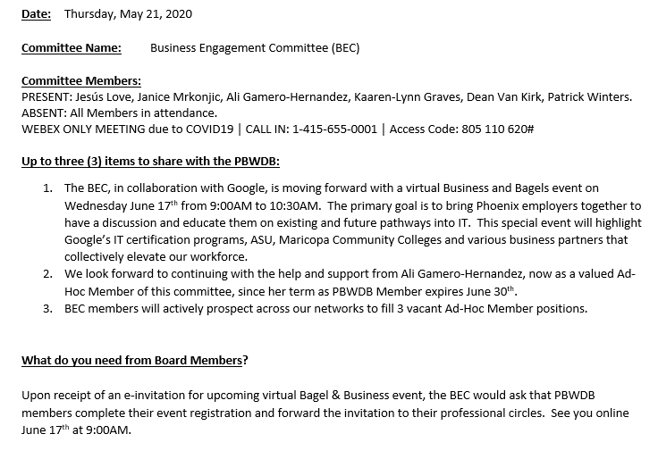

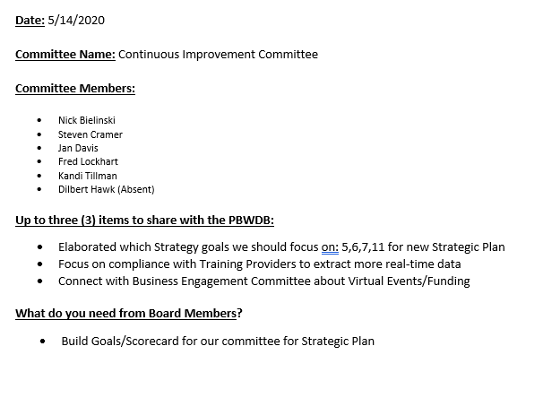

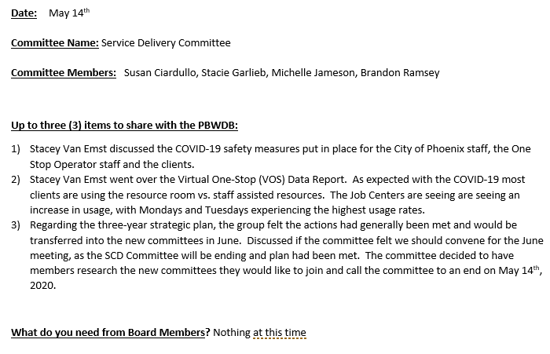

5. Client Referral System (CRS) Update:
One-Stop Operator (OSO) Manager, Michael Burchett, shared that the OSO is still trying to collaborate with the Maricopa County Workforce Development Board (MCWB) on the Client Referral System. Workforce system partners have expressed a desire to have one system across Maricopa County. The OSO is working with MCWDB’s OSO, Maximus, to see if collaboration can occur. The Community and Economic Development’s IT team will ensure that data security is maintained. OSO is striving to have the same referral process as the MCWDB. The next meeting with Maximus is scheduled for the week of June 15th.

At the direction of the City of Phoenix, the OSO was asked to create the system using SharePoint. When creating the partner pages, the information will display services being offered by each partner organization.

Next steps: In the interest of the partner organizations, the OSO will try to work with Maximus to get some continuity between the two Client Referral Systems before moving forward but will not allow this to stall the project.

ELC Vice Chair, Michael Hale, asked for a timeline with measures and outcomes for the Client Referral System. The timeline is shown below.

Client Referral System Implementation Plan

This plan is predicated on commitment, forthrightness, and input from partner organizations. It also assumes there are no other significant distractions such as a more complicated global pandemic.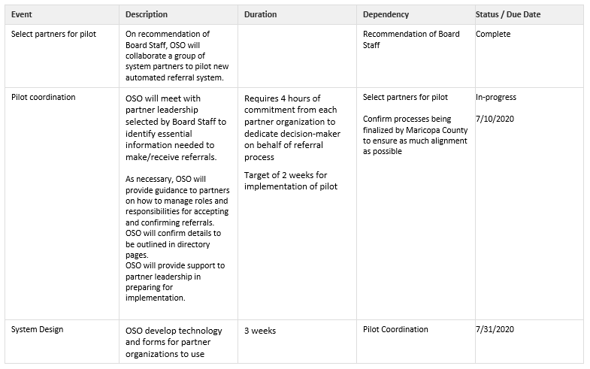
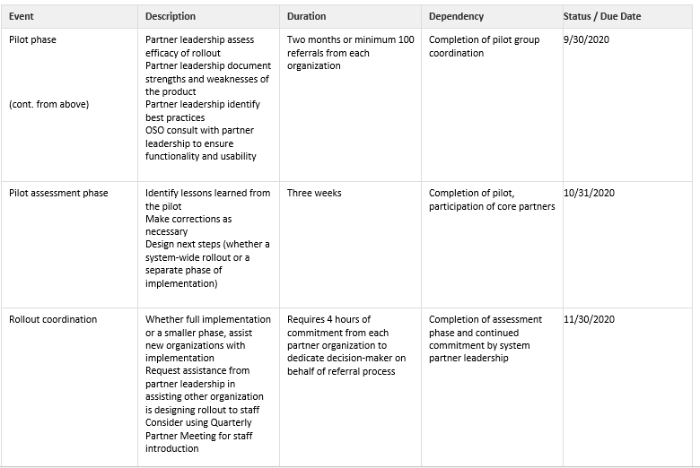
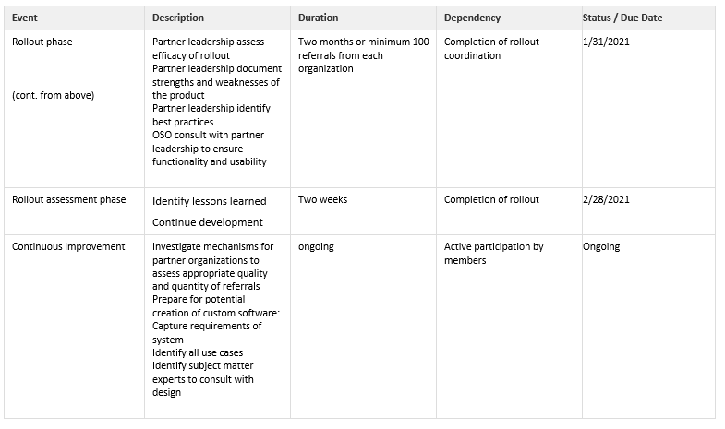

6. Local Plan Status Update:
Local Board Consultant, Dr. Sheila Murphy, shared updates on the progress of the Local Workforce Development Area Plan. A draft version has been developed and Dr. Murphy thanked all the City staff for their valuable input and time answering questions for the Local Plan. The Local Plan will go for public comment around the end of June to allow stakeholders and partners to provide input and comments. The DES provided strict guidelines to develop the Local Plan in guidance that was previously issued. The Local Plan differs from the Strategic Plan in that it asks specific questions that must be answered. The Strategic Plan was helpful in creating the Local Plan and the timing of the Strategic Plan was excellent. An in-depth review of the Local Plan will occur with LaSetta and Christina on Monday, coming to back to the PBWD Board for final approval in June.

7. PBWDB Executive Director Report:
PBWDB Executive Director, LaSetta Hogans, gave an update on the following items:

- WIOA Program Funding Allocations PY20 & PY21 – Information about previous allocations for PY17, PY18 and PY19 were shared with the ELC, along with the program funding allocations for PY20 and PY21. Overall, ARIZONA@WORK City of Phoenix received an increase in federal funding of 2.3 percent. Of note, Governor Ducey has set aside 25% of the Dislocated Worker funds for providing statewide Rapid Response services, therefore, local areas did not receive Rapid Response funding for PY20 and PY21.

- One-Stop Operator (OSO) Services – The existing OSO contract ends June 30, 2021. Board staff have begun working with the City’s procurement team on the process to issue Request for Proposals (RFPs). Board staff will take the request to issue the OSO RFP to Phoenix City Council on August 26, 2020. We will be asking for one or two PBWDB members to join the interview panel for the OSO interviews after the successful proposers have been identified.

8. PBWDB Policy Procedure:
PBWD Board Executive Director, LaSetta Hogans, presented the PBWDB Policy Procedure document to the ELC. Executive Director Hogans highlighted the additions to the procedure including a public comment period for policies and the process for administrative changes to policies. Language was added to the policy procedures that states: If there is a need for clarification regarding the language in the PBWD Board policies, the advice of the City of Phoenix attorney will be taken into consideration.

ELC member Steven Cramer motioned to approve the PBWDB Policy Procedure and ELC Vice Chair Michael Hale seconded.

Approved: Audrey Bohanan, Michael Hale, Daniel Barajas, Nick Bielinski, Steven Cramer, Nick DePorter, Michelle Jameson, Janice Mrkonjic and Bethany Woodard

Opposed: None

Motion passed unanimously

9. ARIZONA@WORK City of Phoenix Policy Review and Draft Approval:
The following policies were presented to the ELC for review and approval:

A. Governance Sec. 900.906 Job Center Certification Policy

B. General Administration Sec. 100.108 WIOA Allowable Costs Policy

ELC Member Steven Cramer motioned to approve draft policies A. and B. and ELC Member Nick Bielinski seconded.

Approved: Audrey Bohanan, Michael Hale, Daniel Barajas, Nick Bielinski, Steven Cramer, Nick DePorter, Michelle Jameson, Janice Mrkonjic and Bethany Woodard

Opposed: None

Motion passed unanimously

10. PBWDB Committee Restructure Discussion:
ELC Chair, Audrey Bohanan, shared they took the Strategic Plan and aligned the committees around the goals. The following information was reviewed in detail:

Program Excellence Committee (PEC)
Goal 1: Instill Hope
Strategy 1
Develop opportunities for individual connections and relationships to support vulnerable populations including youth and dislocated workers.
Strategy 2
Align with local investment in diversity and inclusion as a primary business strategy.
Strategy 3
Show promise for individuals seeking careers through the sharing of simple approaches.

Business and Workforce Engagement Committee (BWEC)
Goal 2: Drive economic mobility and impact.
Strategy 4
Leverage labor market information to inform decisions and strategic impact of Workforce Development.
Strategy 5
Ensure return on investment (ROI) for Workforce Development in the City.
Strategy 6
Invest in educational programs that lead to pre-defined, sustainable Career Pathways and business competitiveness.

Communications and Outreach Committee (COC)
Goal 3: ARIZONA@WORK is the recognized workforce authority in the region.
Strategy 8
Raise external awareness of ARIZONA@ WORK City of Phoenix.
Strategy 9
Build an internal communication strategy.
Strategy 10
Identify and reach the populations we intend to serve and connect them with resources and services.
Strategy 12
ARIZONA@WORK is the single point of contact for hope and direction.

Executive Leadership Committee (ELC) - ELC members are the Chair & Vice Chairs of the three committees listed above, Chair & Vice Chair of the PBWDB.
Strategy 7
Apply existing funding to produce results that demonstrate ROI.
Strategy 11
Focus the funds, tools, and resources to serve people who need assistance in acquiring credentials and work.

- WIOA Budget
- PBWDB Bylaws
- PBWDB Workplan
- Performance Measures Negotiations
- Local Plan
- Memorandum of Understanding (MOU) & Infrastructure Funding Agreement (IFA)
- Shared Local Governance Agreement
- Job Center Certifications
- PBWD Board Recertification
- PBWDB Policies

Chair Bohanan shared that the new ELC members will play a role in each of the key deliverables on the PBWDB Workplan to stay in compliance.

Vice Chair, Michael Hale, shared they want to give all Board members and opportunity to share which committee they would like to be a member of.

ELC Member, Daniel Barajas, wanted to make sure that the Youth requirements under the DES policy are still maintained and that Youth continue to be a focus of the Board. PBWDB Executive Director, LaSetta Hogans, shared the requirements in the DES policy for Youth oversight will need to be added to the Program Excellence Committee’s strategies.

A group of Board members was formed to expand the descriptions of the committees. Nick B., Steven C. and Audrey B. will participate in the teleconference call to finalize committee objectives and descriptions.

The PBWDB Bylaws allow two PBWDB members to serve on the ELC outside of the Chair and Vice Chair roles.

Board staff will send a survey through BoardBookit to all Board and Ad-hoc committee members to identify their first, second and third committee choices. Additionally, members will indicate if they are interested in serving in a Chair or Vice Chair role in the committee. From there, Chair Bohanan and Vice Chair Hale will assign members to a committee and provide notice to the Board members. The goal is for all committees to have their first meeting in July.

ELC Vice Chair Michael Hale motioned to approve the PBWDB Committee Restructure and ELC Member Michelle Jameson seconded.

Approved: Audrey Bohanan, Michael Hale, Daniel Barajas, Nick Bielinski, Steven Cramer, Nick DePorter, Michelle Jameson, Janice Mrkonjic and Bethany Woodard

Opposed: None

Motion passed unanimously

11. Matters for Future Discussion

- ELC Member, Bethany Woodard, partnered with an individual who facilitated a forum for black business owners to come together with workforce. Member Woodard wanted to see if we could get this individual on the schedule to present to the PBWDB.

- ELC Vice Chair, Michael Hale, regarding the Board recertification process and if other Boards in the area are not certified, we would like input on how those funds would be allocated to other Boards in the state if a Board is not certified and what percentage of funds we would receive. Executive Director Hogans shared that attending the Workforce Arizona Council Performance Excellence Committee meeting and speaking during the public comment period would be a good idea.

12. Call to the Public and Open Discussion
None

13. Adjournment
A motion to adjourn the meeting was made at 10:36 a.m. by ELC Member Nick Bielinski and seconded by ELC member Michelle Jameson.

Approved: Audrey Bohanan, Michael Hale, Daniel Barajas, Nick Bielinski, Steven Cramer, Nick DePorter, Michelle Jameson, Janice Mrkonjic and Bethany Woodard

Opposed: None

All were in favor and the meeting adjourned at 10:36 a.m.

