Phoenix Business and Workforce Development Board
Executive Leadership Committee Meeting Minutes
October 10, 2019 ~ 8:30 a.m.

The meeting of the Phoenix Business and Workforce Development Board Executive Leadership Committee was held on October 10, 2019 located at Phoenix City Hall, 200 W. Washington St., 20th Floor, Phoenix, AZ 85003.

Committee Members Present:

Audrey Bohanan (Chair)
Michael Hale (Vice Chair)
Janice Mrkonjic
Susan Ciardullo
Bethany Woodard Michelle Jameson
Nick Bielinski
Jesus Love
Steven Cramer

Committee Members Absent:
Nick DePorter
Daniel Barajas

Public Attendees:

Kerri Barnes
Stacey Van Emst
Silvia Valadez Eddie Barajos
Rob Stenson
Eric Johnson
LaSetta Hogans (PBWDB Executive Director)
Sheila Murphy
Tracey Regenold
Michael Burchett
Mark Carr

Isis Sanchez

Action items taken are noted in bold print.

- Call to Order
PBWDB Chair Audrey Bohanan called the October 10, 2019 Phoenix Business and Workforce Development (PBWD) Board Executive Leadership Committee (ELC) Meeting to order at 8:31 a.m. Roll call was completed, and quorum was met with nine members in attendance.

- Approval of Minutes for August 8, 2019 Meetings:
ELC member Jesus Love requested additional language be added to the minutes for agenda item 6- Adult Education Presentation to accurately reflect the conversation around the agenda item at the previous ELC meeting.
ELC Vice Chair Michael Hale made a motion to approve minutes for the August 8, 2019 meeting, with the requested amendments, and ELC member Janice Mrkonjic seconded.

Approved: Audrey Bohanan, Michael Hale, Nick Bielinski, Susan Ciardullo, Steven Cramer, Michelle Jameson, Jesus Love, Janice Mrkonjic and Bethany Woodard

Opposed: None

Motion passed unanimously

- PBWD Board Consultant Contract Award
Community and Economic Development Department Procurement Manager, Gretchen Wolfe, shared with the committee that the local board consultant Request for Proposal (RFP) was issued on July 1, 2019. Three proposals were received back, however one was deemed nonresponsive. The procurement process moved forward with two proposers, and with one receiving the final award. Dr. Sheila Murphy LLC was awarded the local board consultant contract award.

Dr. Sheila Murphy and Tracey Regenold were present at the ELC meeting, introduced themselves to the committee and answered several questions from committee members.

- PBWDB Committee Updates

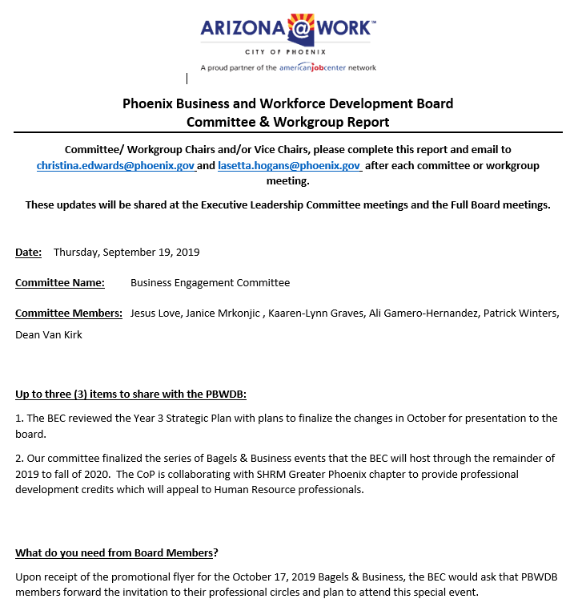
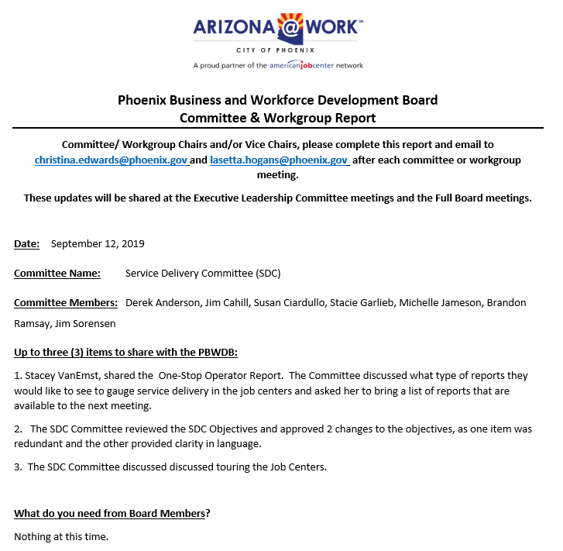

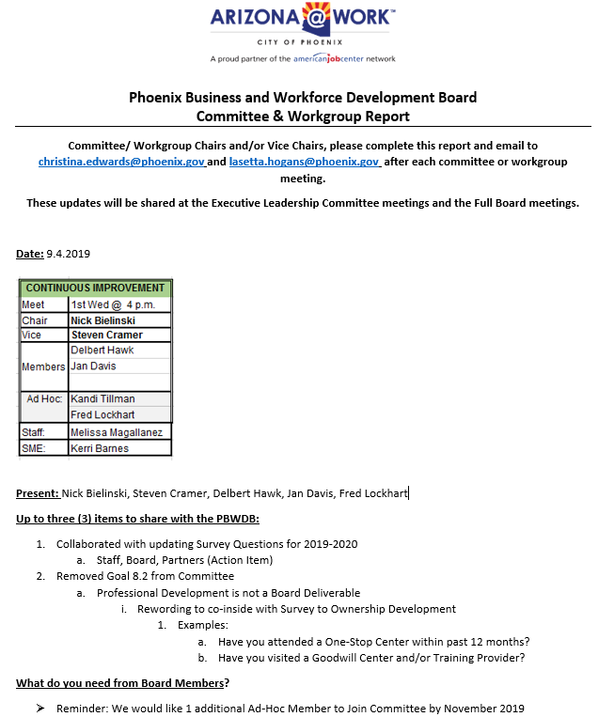
Advancing Youth Workforce Committee (AYWC):

AYWC Member, Bethany Woodard, shared that her committee has been working towards refining the strategic plan scorecard goals and creating goals that are measurable and have meaning. Ms. Woodard shared that the AYWC Youth Ambassador Workgroup recently completed the process to allow a youth ad-hoc member to join the committee. The new ad-hoc member, Ryan, has officially started with the committee and is currently doing a work experience with the City of Phoenix, that includes his membership on the AYWC. Ms. Woodard is currently working on a corporate ask letter to expand the work experience for the youth ad-hoc member.

- PBWDB Shared Local Governance Agreement
PBWDB Executive Director, LaSetta Hogans, gave an update to the committee on the Shared Local Governance Agreement (SLGA). Mrs. Hogans thanked the committee for providing comments and feedback on the agreement. The SLGA has been completed and a final draft was submitted to the Department of Economic Security (DES) on September 30th, along with other documents needed for Board Recertification. DES responded by saying everything looks good and we can move forward with the SLGA. DES asked to have included in the SLGA organizational charts to further clarify the firewall between the Board and Career Services.

Next Steps: Awaiting DES review/approval of the Program Operator Agreement. Once that is approved it will be added to the SLGA as one complete document. The SLGA will go to the PBWDB meeting for approval on November 14th and to the Phoenix City Council on November 20th for final approval.

Mrs. Hogans introduced Community and Economic Development Department Deputy Director, Eric Johnson, and thanked him for his leadership in assisting with the development of the SLGA.

- PBWDB Policy Management Language
PBWDB Executive Director, LaSetta Hogans, reviewed the proposed policy management language with the committee. The policy management language was clarified with the assistance of the City attorney and presented to the committee for approval.

After discussion by committee, all policies, before they come to the PBWDB, will be reviewed by Executive Director, LaSetta Hogans. If the policy changes cause the intent/essence of the policy to change, they will be sent back to the ELC for review. Policy changes may be reviewed by the City attorney and confirmed by email. Any administrative changes to policies will require notice to the ELC. Policy administrative changes will be highlighted and presented to the ELC for approval as a consent agenda item. If a committee member wants to discuss the policy changes, it can be moved from the consent agenda and discussed.

ELC Member Steven Cramer requested to see the process in place for approving Board policies to include the process for a dispute on the policy language. PBWDB Executive Director, LaSetta Hogans, shared that those processes will be updated in the Policy Procedure Document for ELC’s review.

A) ELC member Nick Bielinski made a motion to approve the PBWDB policy management language to be added to the Policy Procedures document, and to be added to all existing youth program policies Section 300.301 through 300.311, with policy administrative changes highlighted and presented to the ELC and ELC member Janice Mrkonjic seconded.

Approved: Audrey Bohanan, Michael Hale, Nick Bielinski, Susan Ciardullo, Steven Cramer, Michelle Jameson, Jesus Love, Janice Mrkonjic and Bethany Woodard

Opposed: None

Motion passed unanimously

B) ELC member Steven Cramer made a motion to approve the PBWDB policy management language to be added to the Policy Procedure document, and to be added to all policies in Sections 100-107; 201-206; 401-413; 501-502; 601-606; 701-709; 801-804; and 901-906, with policy administrative changes highlighted and presented to the ELC, and how disputes on policy language will be addressed in the Policy Procedures document and ELC member Susan Ciardullo seconded.

Approved: Audrey Bohanan, Michael Hale, Nick Bielinski, Susan Ciardullo, Steven Cramer, Michelle Jameson, Jesus Love, Janice Mrkonjic and Bethany Woodard

Opposed: None

Motion passed unanimously

- Incumbent Worker Training Policy
City of Phoenix Business Services Team Supervisor, Rob Stenson, shared the changes to the Incumbent Worker Training (IWT) policy with the committee. The majority of the changes were administrative, with the exception of one significant change, which needs committee approval. All IWT applications will now be aligned with an IWT Rubric when determining eligibility. Mr. Stenson reviewed each category of the IWT Rubric to give further explanation to the committee.

ELC member Steven Cramer motioned to approve the Incumbent Worker Training Policy and ELC member Susan Ciardullo seconded.
Approved: Audrey Bohanan, Michael Hale, Nick Bielinski, Susan Ciardullo, Steven Cramer, Michelle Jameson, Jesus Love, Janice Mrkonjic and Bethany Woodard

Opposed: None

Motion passed unanimously

8. PBWD Board Member Recognition Ideas
ELC Chair, Audrey Bohanan, would like committee members to think about how to recognize the work that PBWDB members are doing. Mrs. Bohanan suggested a quarterly or annual recognition in our PBWDB meetings and asked committee members to start thinking about what the recognition might look like. Particularly for those members who are putting in a lot of hours to market ARIZONA@WORK.

9. Labor Market Information/Skills Gap Report
City of Phoenix Business Services Team Supervisor, Rob Stenson, presented the Labor Market Information/Skills Gap Report document to the committee. The information presented was for the 3rd Quarter of 2019. The Labor Market Information presented included labor force information, unemployment rate, educational attainment rate, hiring employers, top five industries in phoenix, top certifications, general wage information and those not in the labor force information.

Mr. Stenson brought attention to the educational attainment rate listed in the LMI section of the document. ELC Member, Jesus Love, requested seeing the educational attainment rate data drilled down to include high school.

Additionally, on the Skills Gap section, Mr. Stenson shared that not all skills gaps are real as often the language regarding skills from employers will not match the language on job seeker resumes, which does not mean the job seeker doesn’t have that skill.

The Skills Gap Report included information by industry sector on the top common/hard skills, top industry certifications, job matching information, unemployment durations, and education vs. work experience information.

ELC Member, Susan Ciardullo, stated we need to figure out where this type of information should be shared. PBWDB Executive Director, LaSetta Hogans, stated the Business Engagement Committee is scheduled to review this document in November and Service Delivery Committee will be reviewing it today. This document needs to be added to the next Continuous Improvement Committee meeting in December.

ELC Chair, Audrey Bohanan, stated after each committee has had a chance to review the information, the committee Chairs can come back to ELC and identity the next steps.

The LMI/Skills Gap document should not be shared with the public. This is an internal document for the PBWDB members only.

10. Reporting Elements
ELC Chair, Audrey Bohanan, stated everyone should be reviewing the reporting elements document at the committee level to determine what reporting elements are important for the committee to see.

11. Executive Leadership Committee Objectives
PBWDB Executive Director, LaSetta Hogans, shared that there was an ask at the previous ELC meeting to share the objectives for this committee as listed in the PBWDB bylaws and provided the updated Committee Objectives document to the ELC for their information.

12. PBWD Board Strategic Plan ELC Scorecard-Year Three Goals
The following goals/strategies were updated on the ELC Year Three Scorecard:

- Goal 4.1 needs to have a tactic added to speak to the Bagels & Business events through June 2020. Kerri Barnes, Quality Assurance Supervisor, can request the ARIZONA@WORK website “hits” from the Department of Economic Security and the ELC will add a tactic around website hits.
- Goal 5.2 was removed from the ELC scorecard.
- Goal 7.1, 7.2, & 7.3 will be reviewed within the PBWDB Strategic Plan to see exactly how this goal should be stated and will revisit it during the December ELC meeting.
- Goal 9.3 status was changed to yellow.

ELC member Jesus Love motioned to approve the changed to the ELC Scorecard Year 3 and ELC member Michael Hale seconded.
Approved: Audrey Bohanan, Michael Hale, Nick Bielinski, Susan Ciardullo, Steven Cramer, Michelle Jameson, Jesus Love, Janice Mrkonjic and Bethany Woodard

Opposed: None

Motion passed unanimously

12. Matters for Future Discussion

- Skills Gap follow-up

- Goal #7 – Will pull language from the PBWDB Strategic Plan and report back to the ELC

- Client Referral System Update

- Update on the draft amendment between Title I and Title II partners (MOU/IFA)

13. Call to the Public and Open Discussion
ELC Member, Janice Mrkonjic, asked Roman (Ryan) Brama to stand up and introduce himself to the ELC. Mr. Brama is the first youth ad-hoc member to the Advancing Youth Workforce Committee.

14. Adjournment
A motion to adjourn the meeting was made at 10:33 a.m. by ELC Member Jesus Love and seconded by ELC member Steven Cramer.

Approved: Audrey Bohanan, Michael Hale, Nick Bielinski, Susan Ciardullo, Steven Cramer, Michelle Jameson, Jesus Love, Janice Mrkonjic and Bethany Woodard

Opposed: None

All were in favor and the meeting adjourned at 10:33 a.m.

