Phoenix Business and Workforce Development Board
Executive Leadership Committee Meeting Minutes
August 8, 2019 ~ 8:30 a.m.

The meeting of the Phoenix Business and Workforce Development Board Executive Leadership Committee was held on June 13, 2019 located at Phoenix City Hall, 200 W. Washington St., 20th Floor, Phoenix, AZ 85003.

Committee Members Present:

Audrey Bohanan (Chair)
Michael Hale (Vice Chair)
Janice Mrkonjic
Susan Ciardullo
Nick DePorter Bethany Woodard
Nick Bielinski
Jesus Love
Steven Cramer

Committee Members Absent:
Daniel Barajas
Michelle Jameson

Public Attendees:

Diane Nakagawa
Kerri Barnes
Stan Flowers
Kweilin Waller
Silvia Valadez Hank Marshall
Rob Stenson
Christina Edwards (PBWDB Liaison)
LaSetta Hogans (PBWDB Executive Director)
Chris Mackay
Mark Carr

Action items taken are noted in bold print.

- Call to Order
PBWDB Chair Audrey Bohanan called the August 8, 2019 Phoenix Business and Workforce Development (PBWD) Board Executive Leadership Committee (ELC) Meeting to order at 8:32 a.m. Roll call was completed, and quorum was met with nine members in attendance.

- Approval of Minutes for June 13, 2019 Meetings:
ELC Vice Chair Michael Hale made a motion to approve minutes for the June 13, 2019 meeting and ELC member Jesus Love seconded.

Approved: Audrey Bohanan, Nick DePorter, Susan Ciardullo, Janice Mrkonjic, Nick Bielinski, Jesus Love and Bethany Woodard

Opposed: None

Motion passed unanimously

- Job Center Certification Workgroup
ELC Chair Audrey Bohanan stated the Job Center Certification Workgroup was established by previous Chair, Nick DePorter to assess both Aeroterra Affiliate Site and the new South Comprehensive Job Center for certification. The workgroup was scheduled to assess these locations during the month of August 2019. The Job Center Certification assessment tool is in the process of being revised by the AZDES, and the new version will be provided for local boards to complete their assessments in 2020. Certification of sites occur every three years and the board will need to re-certify ten (10) of the 12 locations in 2020.

Upon receipt of the revised Job Center Certification assessment tool, the Aeroterra Affiliate Site and the new South Comprehensive Job Center assessments will occur in 2020, along with the other ten (10) locations, to allow re-certifications of all 12 local sites to occur in the same year.
ELC member Steven Cramer made a motion to dissolve the Job Center Certification Workgroup and postone the Job Center Certification assessments to 2020 and ELC member Susan Ciardullo seconded.

Approved: Audrey Bohanan, Michael Hale, Nick DePorter, Nick Bielinski, Janice Mrkonjic, Jesus Love and Bethany Woodard

Opposed: None

Motion passed unanimously

- New PBWDB Committee Membership Assignments
The new PBWDB committee assignments are as follows:
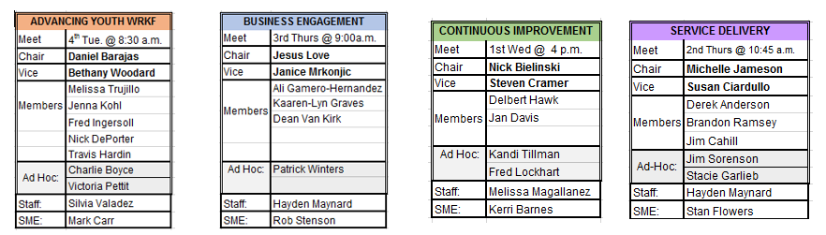

- PBWDB Committee and Workgroup Report
The PBWDB Committee and Workgroup Report draft was shared with the committee for approval. The report will be completed by the Chair and/or Vice Chair of each committee after the committee meeting has concluded. Then, the completed report will be emailed to LaSetta Hogans, PBWDB Executive Director, and Christina Edwards, PBWD Board Liaison. The completed reports will be compiled and placed in the meeting packets for the upcoming ELC or full board meeting. Committee Chair/Vice Chairs will use their written report to share committee progress at each ELC or full board meeting.

ELC member Jesus Love made a motion to approve the PBWDB Committee and Workgroup Report and ELC member Susan Ciardullo seconded.

Approved: Audrey Bohanan, Michael Hale, Nick DePorter, Nick Bielinski, Janice Mrkonjic, Jesus Love and Bethany Woodard

Opposed: None

Motion passed unanimously

- Adult Education Presentation
Jesus Love, PBWDB member and Title II representative of Literacy Volunteers, gave a presentation on the Adult Education Workforce System Funding and an overview of the Yuma Client Referral System (CRS). Mr. Love reached out to the developer/administrator of the CRS and was given authorization to fully implement the CRS in the City of Phoenix. Mr. Love shared that he was thinking he would load the CRS onto his own server to pilot the system and run it by all the stakeholders to see if that would be the way to go. However, in the discussions with stakeholders they felt the progress was moving too fast and decided instead of doing a proof of concept and showed the ELC a presentation to share what the CRS would look like.

Mr. Love shared about a meeting held with the Maricopa County Workforce Development Board, One Stop Operator, and other partners, and a proof of concept for the Client Referral System and utilizing the Title II Adult Education programs available funding to contribute to the Memorandum of Understanding Infrastructure Funding Agreement (IFA) shared costs was discussed. Mr. Love stated that Title II’s funding has not been contributed towards the IFA shared costs in the previous two years and Title II wants to implement something for fiscal year 19/20.

Mr. Love shared that the Yuma Private Industry Council (YPIC) delivers ARIZONA@WORK services in Yuma County and that their CRS includes all of the core partners and workforce partners. The CRS is managed by a YPIC/ARIZONA@WORK administrator/employee. Four to six workforce system partners decide which partners will be in the CRS and what their access and levels of authorization in the system will be. The CRS is a web-based system and no dates of birth and no social security numbers. The CRS sends an automatic email notifying both parties, sender and receiver, and allows the ability to pull reports very easily, including the updates from the receiving party. The CRS is not integrated with the Arizona Department of Economic Security or Adult Education but creates a database tracking who is referring and creates accountability for the referrals. YPIC has provided permission for the City of Phoenix Local Workforce Development Area to use their CRS and a dedicated server. It is unclear who will pilot it.

Mr. Love stated in the IFA, Adult Education as a Title II core partner, has an obligation to share some of the cost of the whole workforce system. Every Adult Education program has a percentage of funding they receive allocated for this purpose and those funds have not been used in two years and the goal is to figure out a way to start using those funds. As an example, Literacy Volunteers has $17,500 available for shared costs towards the IFA but can only disburse it with State authorization based on an amended MOU/IFA being in place for client referrals. Mr. Love stated the purpose is to support Title II students for career training or employment services for co-registration and co-enrollment with primarily Title I-B. PBWDB Executive Director, LaSetta Hogans reminded the ELC that Title I-B includes Adult, Dislocated Worker and Youth program services.

Mr. Love stated Title II is a core partner in the workforce development system with 21 providers, with five in the City of Phoenix. Based on data from FY18 there were 3,400 in Maricopa County. The five providers are Rio Salado Community College, Friendly House, Arizona Center for Youth Resources, Literacy Volunteers and Maricopa County Adult Probation. Mr. Love stated three percent of the awarded Title II funds can be used for system shared costs. None of the programs are co-located. Mr. Love stated the parties need to agree on how to use the funds and the State Adult Education Director needs to sign-off on the agreement. If the funds are not used, they are forfeited.

ELC Chair, Audrey Bohanan, asked how long the funds have been forfeited. Mr. Love responded by saying two years and we are currently in the third year. Mrs. Bohanan asked if we have left money on the table because we have not decided on how to support the work? And asked whose decision was it to make. Was it the PBWDB’s decision to make? Was it someone else who didn’t make the decision? Mrs. Bohanan stated if a decision wasn’t made, what group, individual or organization needs to make that decision, so we don’t leave money on the table? Mr. Love stated the reason why money was left on the table was because there wasn’t clarity on the process to share those funds. Mr. Love stated he really feels it was because there was not a client referral system in place to track clients and that Title II wants verification that there is true partnership in order to share those costs. Mr. Love said this is why we are having this discussion, and this is why the CRS should be put into place.

PBWDB Executive Director LaSetta Hogans reported that the One-Stop Operator, Adult, Dislocated Worker, Youth, Literacy Volunteers and Rio Salado providers have already started these conversations around the percentage of shared cost funds. In previous conversations that Mrs. Hogans has had with Sheryl Hart, Director of Adult Education, she has wanted to ensure there are outcomes and benefits for our Title II partners for contributing funds. The U.S. Department of Labor monitoring that occurred in March resulted in a finding as Title II partners were not identified as contributing to sharing costs in the PBWD Board’s MOU/IFA. The City of Phoenix currently has an IFA with all partners including Title II, but it is “in-kind” and not direct funds. Each Title II provider has their own funding and an agreement with each individual Title II provider needs to be put into place. There have been two addendum templets from Title II that have been reviewed and are under discussion with the Title IB provider.

Goodwill, as the One-Stop Operator, is responsible for the development and implementation of the CRS, as stated in their contract and they have a target due date to have a system in place by June 30, 2020. It is in Goodwill’s scope of work to manage the CRS system. Goodwill will oversee the coordination of the workforce system partners.

City of Phoenix Community and Economic Development Director, Chris Mackay, stated the CRS was in the PBWDB approved procurement plan for fiscal year 19/20 and agreed that we need to get a system in place. Through the city’s procurement process, staff will bring forward solutions to the PBWDB for the CRS. The City would complete the procurement process for the CRS. The City will be the owner of the CRS in the event that the One-Stop Operator contract changes to another vendor.

Mr. Love stated he is confident he can bring all five Title II partners together and come to a consensus on an amendment to the IFA and offered to take the lead in contacting the other partners to add an addendum to the MOU/IFA, so that something is in place to disburse those funds before the end of this fiscal year. He recommends the addendum of the MOU/IFA be provided for review at the next full board meeting, to include the five City of Phoenix Title II partners. There will be five separate addendums with specifics on what services are provided to receive funds and implement that immediately. Mrs. Mackay stated her team will work with the law department to review the addendums prior to the PBWDB’s approval so they can make an appropriate vote.

Mr. Love volunteered to speak with the other three Title II providers in the City of Phoenix to help develop their agreements and present the information at the next full board meeting. Mrs. Mackay stated the City would take the lead on the discussion with the other three providers and would work with Mr. Love if there are issues. Mr. Love stated he would contact the other three Title II providers, obtain the funding amounts, percentages and relevant information, and will provide that information to PBWDB Executive Director, LaSetta Hogans.

PBWDB Executive Director, LaSetta Hogans, stated that the Fiscal Agent will need to work individually with each Title II provider to reach an agreement on terms and funding disbursement. Changes to the MOU/IFA can be done in one single addendum.

Mr. Love proposed bringing the shared costs/CRS issue to the next full board meeting and hopefully will have a consensus on what all the Title II partners agree on in terms of their shared costs funding. The agreement on how to use the shared funds is a PBWDB decision. PBWDB Executive Director, LaSetta Hogans, stated she would share Yuma CRS, 41-page PowerPoint document with the ELC members.

- PBWD Board Presentation Guidelines
The following presentation guidelines were presented to the ELC for individuals to use when developing a presentation to share with the PBWD Board or its committees:
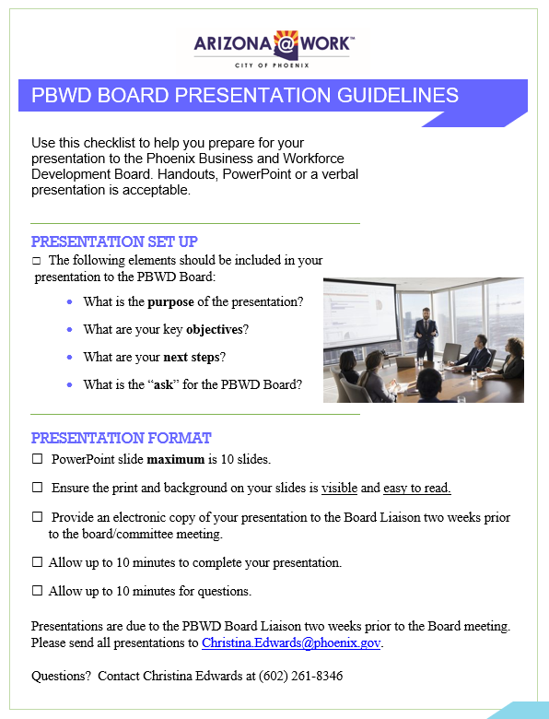

ELC member Jesus Love motioned to approve the PBWD Board Presentation Guidelines and ELC member Susan Ciardullo seconded.
Approved: Audrey Bohanan, Michael Hale, Nick DePorter, Nick Bielinski, Janice Mrkonjic, Bethany Woodard and Steven Cramer.

Opposed: None

Motion passed unanimously

8. PBWDB Committee Objectives Review
ELC Chair, Audrey Bohanan, encouraged ELC members to review the existing Committee Objectives document with their respective committees to ensure the objective accurately reflect the work of the committee.

The ELC will create their objectives at the next committee meeting on October 10th.
9. Youth Ambassador Workgroup Update
Advancing Youth Workforce Committee (AYWC) Vice Chair, Bethany Woodard, shared that the AYWC has created a Youth Ambassador Workgroup (YAW) that will address the process of obtaining two youth ad-hoc members for the AYWC. The YAW includes participation from the youth service providers to help guide the workgroup in making decisions regarding a youth work experience (WEX) and assist in outreach to potential youth ad-hoc members.

The previous YAW meeting centered around ways to incentivize youth monetarily through the WEX. The WEX will consist of 200 hours and may be extended up to 300 hours depending on funding. Efforts are underway to explore part-time or internships with the City of Phoenix that may be applicate for the youth ad-hoc member. The YAW is working with Deputy Human Services Director, Kweilin Waller, who will reach out to City’s departments to see if they have any duties or assignments to incorporate into the WEX. This will give the WEX participant exposure to several City departments. Additionally, efforts around gaining business sponsorship for the ad-hoc youth member WEX extension are being explored. Bethany Woodard asked ELC members to look within their business, or their network of businesses, to see if an opportunity to fund additional WEX hours exists.

10. Shared Local Governance Agreement Update
PBWDB Executive Director, LaSetta Hogans, gave an update on the progress of the Shared Local Governance Agreement (SLGA). The U.S. Department of Labor has provided feedback from their local area visit to ARIZONA@WORK City of Phoenix, which is being used to assist in drafting the SLGA.

One area of concern is the ability for the PBWD Board to avoid any real or perceived conflict of interest in delivering WIOA programs and services. Roles and responsibilities for all parties involved in the SLGA must be clearly outlined and defined. The City of Phoenix legal department has advised the Board to create an Agreement between the City of Phoenix Human Services Department and the Community and Economic Development Department that demonstrates each departments roles and responsibilities in the delivery of programs and services.

The internal due date for the SLGA is October 15, 2019. The Workforce Arizona Council will be approving all local area governance agreements at the November 2019 meeting.

11. PBWD Board Strategic Plan ELC Scorecard-Year Three Goals
The following goals/strategies were updated on the ELC Year Three Scorecard:

- Goal 3.1 was changed to read, “Budget for and acquire technology to track partner referrals.” Tactic 3.1 was changed to read, “Communicate progress with system partners”.
- Goal 3.2 was changed to read, “Continue convening ARIZONA@WORK Quarterly Partner meetings and annual Training EXPO”.
- Goal 5.3 was removed as a Goal and made into a Tactic for Goal 5.1.
- Goal 8 was removed from the Scorecard.
- Goals 9.1, 9.2 and 9.4 were removed from the Scorecard.
- Goal 9.3 was changed to read, “Review dashboard of metrics to be posted on the Board’s website and she with the PBWDB.

12. Matters for Future Discussion
- Review the services we provide through ARIZONA@WORK City of Phoenix and do a side-by-side comparison.

- What interaction do we have with community leaders? What is their input and feedback? Who should we be talking to?

13. Call to the Public and Open Discussion
Youth Program Supervisor Mark Carr thanked the board members for their clothing contributions during the clothing drive for the youth providers. In the future, Mark Carr will provide a clothing needs assessment every quarter and provide that information to the ELC.

14. Adjournment
A motion to adjourn the meeting was made at 10:28 a.m. by ELC Member Janice Mrkonjic seconded by ELC member Nick Bielinski.

Approved: Audrey Bohanan, Michael Hale, Nick DePorter, Susan Ciardullo, Steven Cramer, Jesus Love and Bethany Woodard.

Opposed: None

All were in favor and the meeting adjourned at 10:28 a.m.

