Phoenix Business and Workforce Development Board
Meeting Minutes
May 14, 2020 ~ 8:30 a.m.

VIRTUAL MEETING

Board Members Present:

Audrey Bohanan (Chairwoman) Michael Hale (Vice Chair)
Melissa Trujillo Travis Hardin
Steven Cramer Brandon Ramsey
Jenna Kohl Michelle Jameson
Ali Gamero-Hernandez Jan Davis
Janice Mrkonjic Jesus Love
Nick Bielinski Daniel Barajas
Dean Van Kirk Kaaren-Lyn Graves
Nick DePorter Bethany Woodard
Latasha Causey Brenda Schmidt
Susan Ciardullo James Frolov

Board Members Absent:

Erick Garcia
Yolanda Bejarano

City of Phoenix Staff:
LaSetta Hogans (Executive Director)  Christina Edwards (Board Liaison)  Kimberly Whetstone  Kweilin Waller  Stan Flowers | Mark Carr  Eddie Barajos  Nichole Ayoola  David Chavez  Sandra Enriquez
Chris Mackay  Rob Stenson | Laura Whitehead
Public Attendees:
Michael Burchett Tracey Regenold
Stacey Van Emst Sheila Murphy

- Call to Order
Phoenix Business and Workforce Development (PBWD) Board Chair, Audrey Bohanan, called the May 14, 2020 PBWD Board Meeting to order at 8:44 a.m. Roll call was completed and a quorum of 22 members were present on the phone.

2. Approval of March 12, 2020 and April 14, 2020 Meeting Minutes
A motion to approve the March 12, 2020 and April 14, 2020 Meeting Minutes, was made by PBWD Board Member Janice Mrkonjic, and seconded by PBWD Board Member Tavis Hardin.

Approved: Daniel Barajas, Nick Bielinski, Audrey Bohanan, Susan Ciardullo, Steven Cramer, Latasha Causey, Jan Davis, Nick DePorter, James Frolov, Ali Gamero-Hernandez, Kaaren-Lyn Graves, Michael Hale, Travis Hardin, Michelle Jameson, Jenna Kohl, Jesus Love, Janice Mrkonjic, Brandon Ramsey, Brenda Schmidt, Melissa Trujillo, Dean Van Kirk and Bethany Woodard

Opposed: None

Motion passed unanimously

3. Consent Items
The following Consent Items were presented for approval:

- One-Stop Operator Monthly Reports for February & March
- Career Services Policy Administrative Revisions
A motion to approve consent items was made by PBWD Board Member Janice Mrkonjic and seconded by PBWD Board Member Travis Hardin.

Approved: Daniel Barajas, Nick Bielinski, Audrey Bohanan, Susan Ciardullo, Steven Cramer, Latasha Causey, Jan Davis, Nick DePorter, James Frolov, Ali Gamero-Hernandez, Kaaren-Lyn Graves, Michael Hale, Travis Hardin, Michelle Jameson, Jenna Kohl, Jesus Love, Janice Mrkonjic, Brandon Ramsey, Brenda Schmidt, Melissa Trujillo, Dean Van Kirk and Bethany Woodard

Opposed: None

Motion passed unanimously

4. WIOA Budget and City Budget Process
Human Services Department Deputy Director, Nichole Ayoola, shared information around the City budget process with the Board members and described the Board’s roles and responsibilities pertaining to the WIOA budget.

Deputy Director Ayoola reviewed a modified version of a budget presentation that was given to the City of Phoenix City Manager’s Office with Board members that detailed the timeline and tasks associated with the budget process. This year, the City was unable to meet with the public during the budgeting process due to the health pandemic restrictions on public gatherings.

Due to COVID-19, the City identified a shortfall in funds due to a loss in tax revenue and proceeded to work the Budget and Research Department to address the shortfall. The adjusted budget was presented back to City Council on May 9, 2020. At that time, the City Manager directed all City departments to identify 25% in cuts and send the information to the Budget and Research Department. The cuts are in anticipation of a shortfall in the FY20 City budget. The modified City budget will go back to City Council in June for review and possible approval. Deputy Director Ayoola shared the City of Phoenix is required to have a balanced budget by July 1.

The Board member’s role in the budget process is to oversee WIOA funds coming into the City of Phoenix and to determine where those funds should be allocated within the Adult, Dislocated Worker and Youth programs. The Board also needs to ensure compliance with the use of WIOA funds as there are specific requirements under the law. Additionally, the Board needs to focus on leveraging WIOA funds within the community through partnerships with other entities.

Deputy Director Ayoola reiterated the importance of looking at the current economic conditions when allocating WIOA funds to the various programs. PBWDB Executive Director, LaSetta Hogans, shared that the PBWDB is a local workforce board and as such, has the responsibility of negotiating WIOA funding allocations from DES and to ensure that the local workforce board is a good steward of the WIOA funds.

PBWDB Chair, Audrey Bohanan, shared that the Phoenix City Council meeting calendar is in BoardBookit for anyone who would like to join a City Council meeting.

Deputy Director Ayoola encouraged Board members to listen in on the upcoming City Council meetings as they will be discussing the City budget and the use of federal funds received by the City of Phoenix for COVID-19.

5. Strategic Plan Presentation
Board Consultant, Dr. Sheila Murphy, shared the draft Strategic Plan with the members. Dr. Murphy expressed gratitude and congratulations to the Board and stakeholders for their work on the Strategic Plan. The Strategic Planning Retreat was a huge success and the work done during the retreat is reflected in the Strategic Plan.

Dr. Murphy stated a Strategic Plan one-page overview document was developed, per PBWDB Chair Bohanan’s idea, that conveniently displays the vison and mission of the Board, as well as the goals and 13 functions of the Board, developed during the Strategic Plan Retreat. This document can be utilized by the Board members as a quick reference to the Strategic Plan when engaging with the community.

Dr. Murphy briefly reviewed all the pages of the Strategic Plan with the Board members and thanked Susan Roger and Riana Abrigada, City of Phoenix staff, for their work in staging the room for the retreat.

A motion to approve the PBWDB Strategic Plan was made by PBWD Board Member Janice Mrkonjic and seconded by PBWD Board Member Susan Ciardullo.

Approved: Daniel Barajas, Nick Bielinski, Audrey Bohanan, Susan Ciardullo, Steven Cramer, Latasha Causey, Jan Davis, Nick DePorter, James Frolov, Ali Gamero-Hernandez, Kaaren-Lyn Graves, Michael Hale, Travis Hardin, Michelle Jameson, Jenna Kohl, Jesus Love, Janice Mrkonjic, Brandon Ramsey, Brenda Schmidt, Melissa Trujillo, Dean Van Kirk and Bethany Woodard

Opposed: None

Motion passed unanimously

6. WIOA Procurement Plan
Kimberly Whetstone, City of Phoenix Community and Economic Development Department, reviewed the Procurement Plan shown below with the Board.

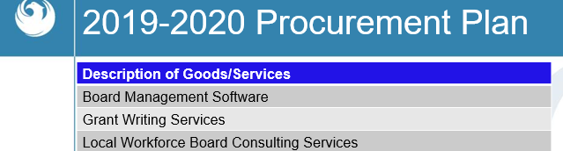

A motion to approve the WIOA Procurement Plan was made by PBWD Vice Chair Michael Hale and seconded by PBWD Board Member Daniel Barajas.

Approved: Daniel Barajas, Nick Bielinski, Audrey Bohanan, Susan Ciardullo, Steven Cramer, Latasha Causey, Jan Davis, Nick DePorter, James Frolov, Ali Gamero-Hernandez, Kaaren-Lyn Graves, Michael Hale, Travis Hardin, Michelle Jameson, Jenna Kohl, Jesus Love, Janice Mrkonjic, Brandon Ramsey, Brenda Schmidt, Melissa Trujillo, Dean Van Kirk and Bethany Woodard

Opposed: None

Motion passed unanimously

7. PBWDB Work Plan
PBWDB Executive Director, LaSetta Hogans, shared the following workplan with the Board.

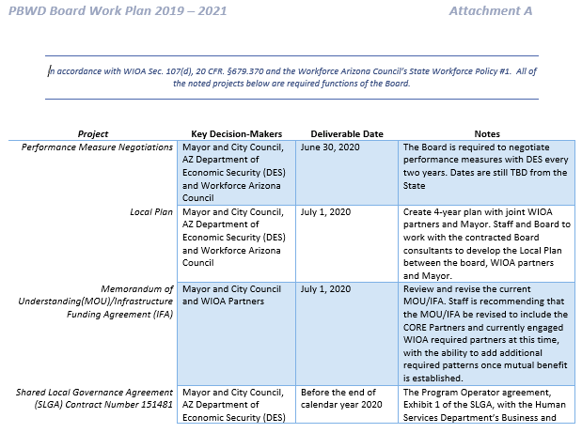

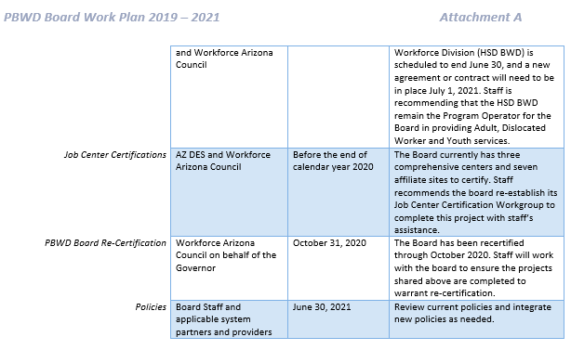

Executive Director Hogans stated that the workplan was developed to be in line with the Board’s mission, vison and Strategic Plan, as well as the contractual commitments with the State and Federal government. Adoption of the workplan provides a mechanism for communication with the Board and gives Executive Director Hogans the ability to provide updates to the Board on the workplan items. Additionally, the workplan provides a framework on the priorities of the Board and ensures the Board’s compliance with Workforce Arizona Council policies. With the Board’s approval of the workplan, it will be updated by staff on an annual basis.

Executive Director Hogans briefly reviewed all items on the workplan with the Board members.

PBWDB Vice Chair, Michael Hale, asked what the Board will lose if we are not recertified and wants all the Board members to understand the significant importance of Board recertification. Executive Director Hogans explained that if the PBWD Board is not recertified then there are steps the Workforce Arizona Council will take in consultation with the Governor. There are policies around recertification, but essentially, if a workforce board is not recertified there is a decertification process, in consultation with the U.S. Department of Labor, and all WIOA funding to the Board stops and the Board is dissolved. All Board recertifications are processed through the Workforce Arizona Council’s Performance Excellence Committee.

PBWDB Member, Jesus Love, reminded the Board that the new Memorandum of Understanding (MOU) and Infrastructure Funding Agreement (IFA) are in effect on July 1, 2020 and Member Love does not want to see the $107,000 in Title II funds left on the table from previous years continue to happen with this MOU/IFA iteration. Executive Director Hogans thanked Member Love for bringing up the concern and stated Board staff are currently making updates to the MOU and it will be reviewed with the core and required workforce system partners soon.

A motion to approve the PBWDB Work Plan was made by PBWD Board Member Steven Cramer and seconded by PBWD Board Member Brandon Ramsey.

Approved: Daniel Barajas, Nick Bielinski, Audrey Bohanan, Susan Ciardullo, Steven Cramer, Latasha Causey, Jan Davis, Nick DePorter, James Frolov, Ali Gamero-Hernandez, Kaaren-Lyn Graves, Michael Hale, Travis Hardin, Michelle Jameson, Jenna Kohl, Jesus Love, Janice Mrkonjic, Brandon Ramsey, Brenda Schmidt, Melissa Trujillo, Dean Van Kirk and Bethany Woodard

Opposed: None

Motion passed unanimously

8. Committee Update Reports
PBWDB Chair, Audrey Bohanan, reviewed each completed committee scorecard with the Board and invited committee chairs and vice chairs to speak about the work of their committees. The scorecards are tied to the existing Strategic Plan which expires or June 30, 2020.

PBWDB Member, Jesus Love, shared information from the Business Engagement Committee around the upcoming Bagels & Business event which will feature Google and Coursera learning. Member Love invited all Board members to attend the event.

PBWDB Member, Daniel Barajas, shared that the Advancing Youth Workforce Committee supports the City of Phoenix staff in developing the Program Year 2020-2021 Request for Proposal (RFP). The committee was sent a survey form the City of Phoenix youth staff asking several questions around youth services to help develop the RFP. Member Barajas shared how best practices will help frame the youth services moving forward.

PBWDB Member, Nick Bielinski, shared that the Continuous Improvement Committee is meeting after the Board meeting to determine exactly what metrics the committee would be looking to see in the future.

PBWDB Member, Susan Cairdullo, shared that the Service Delivery Committee is meeting today after the Board meeting and they haven’t been able to meet since February. The committee will be discussing metrics and changes to service delivery due to COVID.

9. Matters for Future Discussion
- Janice Mrkonjic would like to hear success stories from the frontline staff in the Job Centers at the July meeting.
- Steven Cramer would like to develop metrics around the success of frontline staff in the Job Centers.
- Nick Bielinski would like to see a return-to-work plan for the Job Centers and Business Center.

10. Call to The Public
None

11. Adjournment
A motion to adjourn the meeting was made at 10:09 a.m. by PBWD Board Member Janice Mrkonjic and seconded by Michelle Jameson.

Approved: Daniel Barajas, Nick Bielinski, Audrey Bohanan, Susan Ciardullo, Steven Cramer, Latasha Causey, Jan Davis, Nick DePorter, James Frolov, Ali Gamero-Hernandez, Kaaren-Lyn Graves, Michael Hale, Travis Hardin, Michelle Jameson, Jenna Kohl, Jesus Love, Janice Mrkonjic, Brandon Ramsey, Brenda Schmidt, Melissa Trujillo, Dean Van Kirk and Bethany Woodard

Opposed: None

All were in favor and the meeting adjourned at 10:09 a.m.

