Phoenix Business and Workforce Development Board
Meeting Minutes
May 9, 2019 ~ 8:30 a.m.

The meeting of the Phoenix Business and Workforce Development Board was held on May 9, 2019, located at the Phoenix Business and Workforce Development Center, 302 N. 1st Ave., 6th Floor, Phoenix, AZ 85003.

Board Members Present:

Nick DePorter (Chairman) Michael Hale
Nick Bielinski Travis Hardin
Aubrey Bohanan (Vice-Chair) Susan Ciardullo
Ali Gamero-Hernandez Jesus Love
Janice Mrkonjic Jan Davis
Fred Ingersoll Kaaren-Lyn Graves
Derek Anderson Jenna Kohl
Michelle Jameson

Board Members Absent:

Daniel Barajas Beth Salazar
Bethany Woodard

City of Phoenix Staff:
LaSetta Hogans  Christina Edwards  Kweilin Waller  Christine Mackay  Stan Flowers | Diane Nakagawa  Winsome Benjamin  Mark Carr  Sandra Enriquez  Nichole Ayoola
Laura Whitehead  Joseph MacEwan  Kerri Barnes | Rob Stenson  Silvia Valadez
Public Attendees:
Gina Harper Kim Smith
Dominic Cota Dustin Panoff
Tracey Spire Stacey Van Emst
Michael Burchett Dana Mosley
Shayne Abrahams

- Call to Order
PBWD Board Chairman, Nick DePorter, called the May 9, 2019, Phoenix Business and Workforce Development (PBWD) Board Meeting to order at 8:33 a.m. Roll call was completed by the Board Liaison and a quorum of 15 was present for the meeting.

2. PBWDB Chairman Update
PBWD Board Chairman, Nick DePorter, gave the following update to the Board:

A. Chairman DePorter discussed having a professional clothing drive for the youth and is working with Youth Workforce Supervisor Mark Carr to identify which of our four youth providers need professional clothing. Chairman DePorter encouraged PBWDB members to look in their closets to see what can be donated. Chairman DePorter suggested having board members bring their donated clothing to the next board meeting. Board staff will coordinate the collection of professional clothing with Youth Workforce Supervisor Mark Carr and will email board members with updates.

B. Chairman DePorter discussed having a group lunch for PBWD Board members after the July 11, 2019 Board meeting. Chairman DePorter will work with the new Board officers, as they will be in place by the July meeting, to see if this is feasible. PBWDB Executive Director LaSetta Hogans reminded the Board that the Service Delivery Committee (SDC) meets directly after the Board meetings and that they may be able to move the meeting to allow Board members on the SDC an opportunity to attend. Chairman DePorter stated another option would be to collect money from Board members and have a catered lunch at the Business Center.

C. Chairman DePorter thanked board members and staff for the opportunity to serve as PBWDB Chairman. Chairman DePorter stated it has been an exciting year for him as Chairman and thanked PBWDB Executive Director LaSetta Hogans and PBWD Board Liaison Christina Edwards for their hard work aligning the Board with the new guidelines under the Workforce Innovation and Opportunity Act, streamlining the agendas and making them easier to read, and for setting the Board up for success in the future.

3. Approval of March 14, 2019 Meeting Minutes
A motion to approve the March 14, 2019 Meeting Minutes, was made by Michael Hale, and seconded by Travis Hardin.

Approved: Derek Anderson, Audrey Bohanan, Nick Bielinski, Susan Ciardullo, Jan Davis, Nick DePorter, Ali Gamero-Hernandez, Kaaren-Lyn Graves, Fred Ingersoll, Michelle Jameson, Jenna Kohl, Jesus Love and Janice Mrkonjic.

Opposed: None

Motion passed unanimously

4. Consent Items
The following items were presented to the PBWDB for approval:

- WIOA Title II Third Quarter Report
- One-Stop Operator Monthly Reports for February and March
- ARIZONA@WORK City of Phoenix Policy DRAFT Approval
  - Youth Services Sec. 300.310 Work Experience Agreements
  - Youth Services Sec. 300.311 Youth Occupational Skills Training
  - Strengthening Working Family Initiative (SWFI) Sec. 400.409 Program Subrecipient Monitoring
  - SWFI Sec. 400.410 Fiscal Subrecipient Monitoring
  - SWFI Sec. 400.411 Records Management
  - SWFI Sec. 400.412 Leveraged Resources
  - SWFI Sec. 400.413 Cash Management
A motion to approve Consent Items A-C was made by Susan Ciardullo, seconded by Audrey Bohanan.

Approved: Derek Anderson, Nick Bielinski, Jan Davis, Nick DePorter, Ali Gamero-Hernandez, Kaaren-Lyn Graves, Michael Hale, Travis Hardin, Fred Ingersoll, Michelle Jameson, Jenna Kohl, Jesus Love and Janice Mrkonjic.

Opposed: None

Motion passed unanimously

5. PBWDB Executive Director’s Report
PBWD Board Executive Director, LaSetta Hogans, updated the board with the following items:

During this reported timeframe staff assisted the Board in addressing and taking appropriate action on the following matters:

- Attended the National Association of Workforce Boards (NAWB).

  - Had the opportunity to meet with Sylvia Lee, Legislative Assistant for Senator Kyrsten Sinema, Jeff Finegan, Legisislative Assistant for Senator Martha McSally, Nathan Schelbe, Legislative Director for Congressman Ruben Gallego, and Congressman Greg Stanton.

  - Attended an Executive Director Bootcamp offered for through NAWB for new leaders.
PBWDB Executive Director LaSetta Hogans shared that Marchelle Franklin, City of Phoenix Human Services Director, Kweilin Waller, City of Phoenix Human Services Deputy Director and herself went to Washington, D.C. to attend the NAWB conference. This was Executive Director Hogans first time attending the conference and her expectations for the conference were exceeded. The next NAWB conference is scheduled for March 2020 and Executive Director Hogans would like to send Board members to the event. The conference is focused on workforce boards and it makes sense to send PBWDB members.

Executive Director Hogans was able to participate in a “Executive Director’s Bootcamp” at the NAWDB conference, which was geared towards Directors who are new in their roles. The Bootcamp was an excellent way to network with other Executive Directors from around the country. There will be two more sessions for the Bootcamp, which will occur in Missouri and Kansas. As Executive Director Hogans completes each session she will bring information back to the Board to share.

Executive Director Hogans shared that she was able to meet with congressional leaders while in Washington, D.C. for the NAWB conference. Executive Director Hogans met with Sylvia Lee, Legislative Assistant for Senator Kyrsten Sinema, Jeff Finegan, Legisislative Assistant for Senator Martha McSally, Nathan Schelbe, Legislative Director for Congressman Ruben Gallego, and Congressman Greg Stanton. The City of Phoenix has access to government liaisons, the law firm of Holland and Knight, that worked to set up meetings with the congressional leaders during the D.C. visit. The liaisons were there to attend the meetings and push agenda items forward on the city’s behalf. The reauthorization of WIOA was discussed with congressional leaders as well as the appropriation of workforce funds and getting those funds to the local areas. Executive Director Hogans will continue to work closely with Holland and Knight to keep important workforce items on the congressional agenda.

Chairman DePorter asked Executive Director Hogans if the elected officials had a good understanding of the workforce issues. Executive Director Hogans indicated that Greg Stanton has a good understanding of the issues as he was the City of Phoenix Mayor and was involved in workforce initiatives. The remaining congressional staffers rneeded more education surrounding workforce and were very responsive to the information that was shared.

Chairman DePorter shared the need to diversify funding and continue looking as ways to acquire funding outside of WIOA.

PBWDB Member Michael Hale asked if there was any discussion with the congressional leaders on Return on Investment (ROI). Executive Director Hogans stated there was not specific discussion related to ROI, or data shared, but that best practices throughout the country were shared.
- Attended the Phoenix Economic Development & Workforce Symposium sponsored by AAED.

- Lead and facilitated a SWFI Workgroup.

- Monthly meetings held with Maricopa County Board Executive Director and participation on their Regional Sustainability Workgroup.

- Bi-weekly meetings held with the One-Stop Operator, Goodwill of Central and Northern Arizona resulting in progress/performance updates.

- Summer Youth Employment preparation meetings with Youth Operations Team.

- Continued meetings with Procurement team re: Scope of Work for Board Strategic Plan and next Local Plan 2020-2024.

- Reviewing/updating Work-Based Learning Grant Contracts and Procedures with QA and Business Team.

- Researching A/V technology for Board Meetings.

- Reviewing and updating MOU between Library Department and CEDD for the hive@central Partnership.
Items to discuss with Board:
- Youth Build Grant Application Status

PBWDB Executive Director LaSetta Hogans stated that the City of Phoenix was not awarded the YouthBuild grant but has the option of going after the grant again in the next funding cycle. A summary report sharing why the City of Phoenix was not awarded the Youthbuild grant will be obtained and shared with the PBWD Board.

- Board Retreat
PBWDB Executive Director LaSetta Hogans shared that we are going to have a Board Retreat this summer (June, July, August) and asked that Board members share topics of discussion for the retreat. The following topics were suggested:
1. Getting to know you segment – Board members share what they
do and how it can impact the work of the Board.
2. How does the Board collaborate regionally?
3. Can we invite publicly elected officials to speak? Or DES/ DOL?
4. What are the creative ways the Board can use WIOA funds?
5. Strategic Planning- SWOT analysis
6. Understand the status of workforce in the City of Phoenix.
How are we currently performing? What are the numbers telling
us? Cost information to deliver services. ROI
7. What does the future of workforce look like from an economic
development standpoint.
8. How do we scale ourselves? Make big projects bigger.
9. Technology. Are we using it to the best of our ability? How do
we leverage technology to do better?
10. Can employer sponsors help fund a portion of the day?

6. PBWDB Committee Updates

AYWC: Committee Member, Travis Hardin, stated the committee is excited and working to revamp themselves. The committee is taking another look at the strategic plan and restructuring some of the goals. Moving forward, the committee is looking to educate our partners on the importance of hiring youth and become data mindful using data to address gaps in service.

BEC: Committee Chair, Michael Hale, reported that the committee is very engaged. The Bagels and Business event was held yesterday, and the topic of the event was Emotional Intelligence. Chairman Hale commended his committee members, and Chairman DePorter, for attending the Bagels and Business event. The committee members engaged attendees and worked to spread the message of the PBWD Board.

Committee members are engaged all around the valley. The Heroes of Education meeting was recently held, and committee members were in attendance. The Hispanic Chamber of Commerce Black and White Dinner was attended by BEC members, as well.

The ABS sector partnership meeting is next week, as well as the BEC meeting. The next Bagels and Business event topic has not been identified yet. There is a desire to have C level employees at the table for future Bagels and Business events.

CIC: Committee Chair, Audrey Bohanan, reported that the committee met at the North Job Center for their last committee meeting. The committee reviewed the scorecard and made some adjustments. The CIC watched an educational video on median earnings through Workforce GPS. As the CIC reviews data, they need to learn what the measures mean, and the Workforce GPs videos are a great way to do that.

SDC: Committee Chair, Michelle Jameson, reported that the committee reviewed the Business Services Team surveys and are looking forward to new surveys to gauge collaboration between the career advisors and the business services team members. The committee reviewed AMS materials and notes from the Integrated Service Delivery meetings. They also reviewed what good customer service looks like and how it is measured.

7. Aeroterra Affiliate Site and South Job Center One Stop Certification
PBWDB Chairman, Nick DePorter, stated that two additional members are needed for the Job Center Certification Workgroup that was created in March at the Executive Leadership Committee meeting. Chairman DePorter invited PBWDB Vice Chair, Audrey Bohanan, to share her experiences in participating in the Job Center Certification Workgroup in the past. Vice Chair Bohannan shared her experiences and encouraged PBWDB members to join the workgroup to gain valuable knowledge on ARIZONA@WORK services in the job centers.

PBWDB members Michael Hale, Nick DePorter, Nick Bielinski, Michelle Jameson and Bethany Woodard volunteered to join the Job Center Certification Workgroup.

A motion to approve the addition of new members to the PBWDB Job Center Certification Workgroup was made by Janice Mrkonjic, seconded by Jesus Love.

Approved: Derek Anderson, Audrey Bohanan, Nick Bielinski, Susan Ciardullo, Jan Davis, Nick DePorter, Ali Gamero-Hernandez, Kaaren-Lyn Graves, Michael Hale, Travis Hardin, Fred Ingersoll, Michelle Jameson, Jenna Kohl.

Opposed: None

Motion passed unanimously

8. Business and Workforce Development Budget Update
Human Services Department, Deputy Director, Nichole Ayoola, shared the fiscal year 18/19 and 19/20 budget allocations and fiscal year 18/19 expenditures.

A motion to approve the Fiscal Year 18/19 and 19/20 Budget Allocations, and the Fiscal Year 18/19 Expenditures, was made by Michael Hale, and seconded by Travis Hardin.

Approved: Derek Anderson, Audrey Bohanan, Nick Bielinski, Susan Ciardullo, Jan Davis, Nick DePorter, Ali Gamero-Hernandez, Kaaren-Lyn Graves, Fred Ingersoll, Michelle Jameson, Jenna Kohl, Jesus Love and Janice Mrkonjic.

Opposed: None

Motion passed unanimously

9. Performance Measures: Negotiations and Outcomes
Acting Deputy Human Services Director, Kweilin Waller and Human Services Department, Workforce Program Manager, Stan Flowers, shared information related to WIOA performance measures. Mr. Flowers explained how performance measures are negotiated with the Arizona Department of Economic Security and what the outcomes are. All four titles under WIOA have performance measures in common. Mr. Flowers gave a detailed explanation on what the Adult, Dislocated Worker and Youth performance measures are and how the information is captured for reporting purposes.

The federal WIOA performance measures:
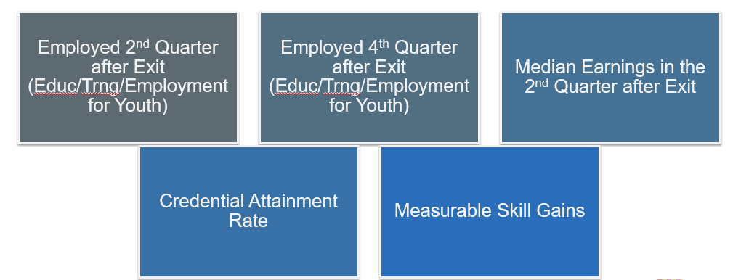

Program Year 2018 and 2019 Goals – At a Glance:
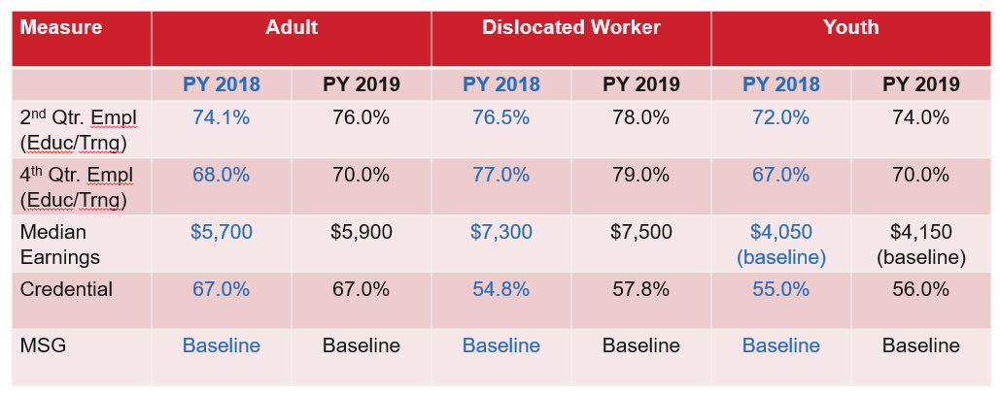

10. Work Based Learning Programs Update
Community and Economic Development Department, Business Services Supervisor, Rob Stenson, gave an overview of work-based learning programs to include On-the-job Training, Customized Training, Incumbent Worker Training and various cohort programs.

Mr. Stenson explained the requirements for each type of training program, the benefit of the training programs for employees, job seekers and employers, and the amount of funds allocated to the training programs for fiscal year 18/19. Mr. Stenson reviewed the ARIZONA@WORK City of Phoenix targeted industry sectors, which include Advanced Business Services, Healthcare, Construction, and Information Technology. Employers wishing to use any of the work-based learning programs must be in one of the targeted industry sectors.

11. hive@central Extension
PBWDB Chair, Nick DePorter, shared that the hive@central has requested an extension on WIOA funding in the amount of $35,000 to fund the Business Roadmap Program/ MAPA Para su Negocio Series at Phoenix Public Library Branches for program year 19/20.

This funding was previously approved by the PBWD Board on November 8, 2018 for program year 18/19, however, the entrepreneurial/small business programs were not implemented due to procurement processes and the need to hire staff, and funding was not distributed.
A motion to approve the hive@central funding for program year 19/20 in the amount of $35,000 was made by Audrey Bohanan and seconded by Fred Ingersoll.

Approved: Derek Anderson, Nick Bielinski, Susan Ciardullo, Jan Davis, Nick DePorter, Ali Gamero-Hernandez, Kaaren-Lyn Graves, Michael Hale, Travis Hardin, Michelle Jameson, Jenna Kohl, Jesus Love and Janice Mrkonjic.

Opposed: None

Motion passed unanimously

12. PBWD Board Officer Election Results
PBWD Board Chair, Nick DePorter, shared the election results for the PBWDB Chair and Vice Chair officers for program years 19/20 and 20/21.

Chair – Audrey Bohanan
Vice Chair – Michael Hale

A motion to approve PBWDB Officers, Audrey Bohanan as Chair and Michael Hale as Vice Chair, effective July 1, 2019, was made by Janice Mrkonjic, seconded by Jesus Love.

Approved: Derek Anderson, Nick Bielinski, Audrey Bohannan, Susan Ciardullo, Jan Davis, Nick DePorter, Ali Gamero-Hernandez, Kaaren-Lyn Graves, Michael Hale, Travis Hardin, Fred Ingersoll, Michelle Jameson and Jenna Kohl.

Opposed: None

Motion passed unanimously

13. Matters for Future Discussion
PBWD Board member, Michelle Jameson, shared that she is participating in the Maricopa County Regionalism Workgroup where workgroup members are seeking to identify areas where the City of Phoenix and Maricopa County workforce boards can collaborate regionally.

14. Call to the Public and Open Discussion
PBWD Board Member, Travis Hardin, wished all the mothers a Happy Mother’s Day.

15. Adjournment
A motion to adjourn the meeting was made at 10:25 a.m. by Jesus Love, seconded by Audrey Bohanan.

Approved: Derek Anderson, Nick Bielinski, Susan Ciardullo, Jan Davis, Nick DePorter, Ali Gamero-Hernandez, Kaaren-Lyn Graves, Michael Hale, Travis Hardin, Fred Ingersoll, Michelle Jameson, Jenna Kohl, and Janice Mrkonjic.

Opposed: None

Motion passed unanimously, and the meeting adjourned at 10:25 a.m.

