Phoenix Business and Workforce Development Board
Meeting Minutes
July 11, 2019 ~ 8:30 AM

The meeting of the Phoenix Business and Workforce Development Board was held on July 11, 2019, located at the Phoenix Business and Workforce Development Center, 302 N. 1st Ave., 6th Floor, Phoenix, AZ 85003.

Board Members Present:

Audrey Bohanan (Chairwoman) Jim Cahill
Michael Hale (Vice Chair) Travis Hardin
Nick DePorter (Chairman Emeritus) Susan Ciardullo
Jenna Kohl Daniel Barajas
Ali Gamero-Hernandez Jan Davis
Janice Mrkonjic
Nick Bielinski

Board Members via Phone:
Steven Cramer Delbert Hawk
Michelle Jameson Jesus Love
Brandon Ramsey

Board Members Absent:

Derek Anderson
Kaaren-Lyn Graves
Dean Van Kirk

Fred Ingersoll
Melissa Trujillo
Bethany Woodard

City of Phoenix Staff:
LaSetta Hogans (Executive Director)  Silvia Valadez Barba  Kweilin Waller  Stan Flowers | Diane Nakagawa  Mark Carr  Sandra Enriquez  Rob Stenson
Hank Marshall | Dana Mosley
Public Attendees:
Moriah Robles Mary Mitchell
Elizabeth E. Cole Jim Sorenson
Kimberly Smith Dustin Panoff
Cheri Czensinski Stacey Van Emst
Shayne Abrahams Michael Burchett

- Call to Order
Phoenix Business and Workforce Development (PBWD) Board Chairwoman, Audrey Bohanan, called the July 11, 2019 PBWD Board Meeting to order at 8:30 a.m. Roll call was completed and a quorum of 17 members were present, including in person and on the phone.

PBWD Board Chairwoman, Audrey Bohanan, welcomed the new PBWD Board Members and invited them to speak briefly about themselves. Brandon Ramsey who works for Microsoft introduced himself first. He shared his excitement at the opportunity to be part of the PBWD Board. Jim Cahill with the Bricklayers Union introduced himself second and also shared his excitement at the opportunity to be participating in the PBWD Board. Finally, Steven Cramer introduced himself. He shared being excited to be working with the PBWD Board and excited to be able to support both the community and the City of Phoenix (COP). Mr. Cramer is a Co-Chair of the Advanced Business Services, President of the North American Customer Services Management Association and Board Member for the International Customer Services Association. PBWD Board Chairwoman, Audrey Bohanan, welcomed the rest of the Board Members.

2. PBWDB Chairwoman Update
PBWD Board Chairwoman, Audrey Bohanan, thanked everyone for the high participation in committee assignment survey and shared that based on the results, there will be changes to the committee assignments moving forward. Committee members now have the flexibility to serve on more than one committee during their membership terms.

PBWD Board Chairwoman, Audrey Bohanan, shared that she and PBWDB Vice Chair, Michael Hale, will be hosting a mix and mingle breakfast thirty minutes before the next PBWD Board Meeting in September. This is an opportunity for members to get to know each other.

PBWD Board Chairwoman, Audrey Bohanan shared that a report-out template has been created for reporting committee updates. She requested that this template be reviewed during each committee’s next meeting. This template will help facilitate what is reported out as well as bring some structure and consistency to information being reported.

3. PBWDB Vice-Chair Updates
PBWDB Vice Chair, Michael Hale, thanked everyone for their attendance and participation in the PBWD Board. He shared that his aim for the PBWD Board is to move the board’s focus into action; so that 90% of what the PBWD Board does moves the board toward completion of their goals. Additionally, he particularly wanted all the new members to feel enabled and empowered to speak to issues and share their perspectives so that by optimizing everyone’s expertise, things can be accomplished in a timely manner.

4. Approval of May 9, 2019 Meeting Minutes
A motion to approve the January 10, 2019 Meeting Minutes, was made by PBWD Board Member Jan Davis, and seconded by PBWD board Member Janice Mrkonjic.

Approved: Audrey Bohanan, Jim Cahill, Michael Hale, Travis Hardin, Nick DePorter, Susan Ciardullo, Jenna Kohl, Daniel Barajas, Ali Gamero-Hernandez, Nick Bielinski, Steve Cramer, Delbert Hawk, Michelle Jameson, Jesus Love and Brandon Ramsey.

Opposed: None

Motion passed unanimously

5. Consent Items
The following Consent Items were presented for approval:
- hive@central May Report

- One-Stop Operator Monthly Reports for April and May

- ARIZONA@WORK City of Phoenix Policy DRAFT Approval

- Sec. 400-403 Data Integrity and the Customer Participation Cycle

- Sec. 400-407 Performance Measures

- Sec. 400-413 Incentives
- Sec. 200-206 Workforce Preparation Activities - Job Readiness

A motion to approve items A-C was made by PBWD Board Vice Chair, Michael Hale, and seconded by PBWD Board Member, Travis Hardin.

Approved: Audrey Bohanan, Jim Cahill, Janice Mrkonjic, Jan Davis, Nick DePorter, Susan Ciardullo, Jenna Kohl, Daniel Barajas, Ali Gamero-Hernandez, Nick Bielinski, Steve Cramer, Delbert Hawk, Michelle Jameson, Jesus Love and Brandon Ramsey.

Opposed: None

Motion passed unanimously

6. One-Stop Operator (Goodwill) Year End Presentation
The One-Stop Operator (Goodwill) gave a presentation summarizing the job center’s operations for Program Year (PY) 18/19. It was facilitated by Stacey Van Emst and Michael Burchett from Goodwill of Central and Northern Arizona.

PBWD Board Vice Chair, Michael Hale, asked the presenters to think about two or three metrics they would like the PBWDB to keep an eye on. Presenter Stacy Van Emst invited the board members to “secret shop” any of the three ARIZONA@WORK Job Center locations .

7. PBWDB Executive Director’s Report

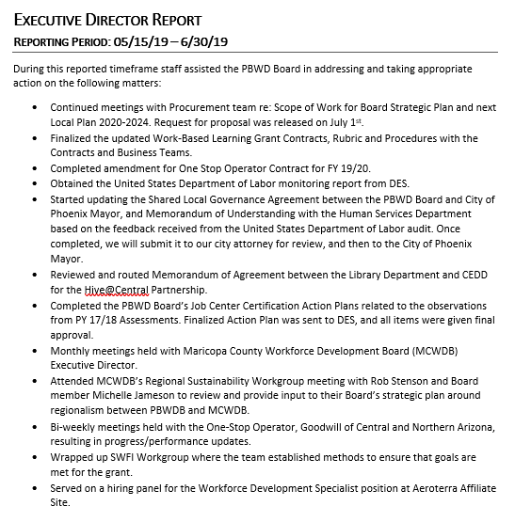

PBWD Board Executive Director, LaSetta Hogans, highlighted the following items from the Executive’s Report:

- PBWD Board Executive Director, LaSetta Hogans, and PBWD Board Liaison, Christina Edwards, have been working with the Procurement Team and the Request for Proposal (RFP) for a board consultant was issued. It is anticipated that the consultant will be on-board within the next few months. The PBWDB Retreat will be postponed until after the consultant has started. PBWD Board Chair Emeritus, Nick DePorter, encouraged everyone to share the RFP opportunity within everyone’s network.

- The One-Stop Operator Contract for Fiscal Year (FY) 19/20 has recently been updated. PBWD Board Executive Director, LaSetta Hogans, will create a summary of the amendment and send it out to the PBWD Board Members.

- PBWD Board Executive Director, LaSetta Hogans, and PBWD Board Liaison, Christina Edwards, have completed the PBWDB Job Center Certification Action Plans from PY 2017. Arizona Department of Economic Security (ADES) has given the action plan their final approval. Moving forward, a work group was created to conduct Job Center Certifications for the South Job Center and the Aeroterra affiliate site in August. A conference call will be set up to go over what this will look like for the work group.

- PBWD Board Executive Director, LaSetta Hogans, briefly reviewed the U.S. Department of Labor Monitoring Report, pointing out that the Department of Labor (DOL) was very impressed with the involvement and engagement of the PBWD Board and the great work coming out of our local area. The City of Phoenix (COP) was noted for a best practice in having all the job centers and youth services in the areas with the highest need populations. Additionally, it was noted that it is the PBWD Board’s responsibility to demonstrate how potential conflict of interest is being addressed. A Shared Local Governance Agreement (SLGA) will address potential conflict of interest and a draft has been created. Based on this DOL report, some revisions will be made to the SLGA and a Memorandum of Understanding (MOU) will be created between the Community and Economic Development Department (CEDD) and Human Services Department (HSD). Board Member Daniel Barajas posed the question if the PBWD Board should put together something identifying the actionable steps the PBWD Board is taking to ensure processes and protocols are where they should be. PBWDB Chair, Audrey Bohanan, suggested adding an item to the next PBWD Executive Committee meeting related to sending out PBWD Board accomplishments to the community. Executive Director Hogans shared that other boards send out annual reports to showcase their accomplishments. Additionally, the DOL Monitoring Report indicated that although there is an existing Workforce System Partner MOU-Infrastructure Agreement (IFA), identifying infrastructure costs, it does not include a methodology for entities not physically located at the ARIZONA@WORK Job Centers. Costs outlined in the IFA should include shared costs with the four core partners, (Tittle I, Tittle II, Title III, Title IV). Conversations regarding these shared costs have started and will continue.

8. PBWDB Committee Updates

CIC: Continuous Improvement Committee Chairman, Nick Bielinski, shared that as they closed out the year and looked at some of the committee’s deadlines for the upcoming quarter, their goals are now being shaped by understanding the metrics, and on understanding the “why” behind the metrics.

BEC: Business Engagement Committee Vice Chair, Janice Mrkonjic, shared that her and Jesus Love drafted a proposal to highlight the four cornerstones (Title I, II, III IV), as a strategic annual event for Bagels and Business with the goals of elevating the number of attendees, as well as encourage repeat attendance. The proposal will be unveiled during their next BEC meeting.

AYWC: Advancing Youth Workforce Committee Chairman, Daniel Barajas, shared that the service providers have been invited to the AYWC table during meetings to share their valuable feedback and expertise. Additionally, he shared that the committee will be adding a Youth Ad Hoc Member to the committee. Youth Program Supervisor, Mark Carr, shared that a workgroup was created to develop a job description for the new Youth Ad Hoc Member. Chairman Barajas also shared that the committee closed out the 18/19 scorecard.

SDC: Service Delivery Committee Chairwoman, Michelle Jameson, shared the committee is down a Vice Chair but does have a couple of qualified people that might be able to fill the position. The committee closed out their year two scorecard. During their next meeting in August they will be reviewing year three scorecard.

9. WIOA Title III Employment Services Presentation
Jim Sorenson, Region III Employment Manager from the Arizona Department of Economic Security, gave a presentation on Title III programs and services.

10. WIOA Title IV Vocational Rehabilitation Presentation
Jan Davis, from the Rehabilitation Services Administration (RSA) for the Arizona Department of Economic Security, gave a presentation on Title IV programs and services.

11. WIOA Adult/Dislocated Training Caps and Industry Sectors
Stan Flowers, City of Phoenix Workforce Program Manager, educated PBWD Board Members on how Title I Adult and Dislocated Worker program training caps are established and how they are tied to the industry sector. He recommended approval to maintain Adult/Dislocated Worker Training caps for the target and non-target sectors.

A motion to approve the Adult/Dislocated Worker Training caps for the target and non-target sectors was made by PBWD Board Member Susan Ciardullo and seconded by PBWD Board Member Janice Mrkonjic.

Approved: Audrey Bohanan, Jim Cahill, Michael Hale, Travis Hardin, Nick DePorter, Jenna Kohl, Daniel Barajas, Ali Gamero-Hernandez, Jan Davis, Nick Bielinski, Steve Cramer, Delbert Hawk, Michelle Jameson, Jesus Love and Brandon Ramsey.

Opposed: None

Motion passed unanimously

12. The Precisionist, Inc (TPI) Presentation
Founder and CEO of The Precisionist (TPI), Ernest Dianastasis, did a presentation on their organization. The Precisionists, Inc. (TPI) is a national company focused on creating 10,000 jobs for people with disabilities by the year 2025, by providing industry best practices for delivering administrative and technology services performed through teams which include individuals with disabilities. TPI plans to expand into the Phoenix Metro Area and are currently working with the City of Phoenix Community and Economic Development Department to secure a location.

13. Youth Build Report
Deputy Human Services Director, Kweilin Waller, provided the following written report to the PBWD Board for review.

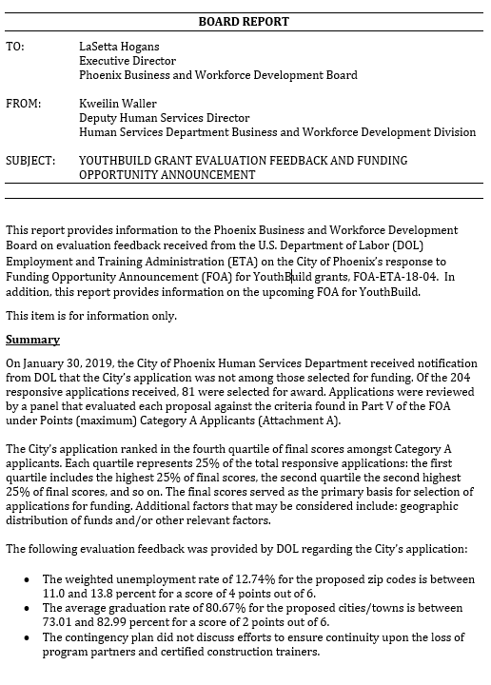
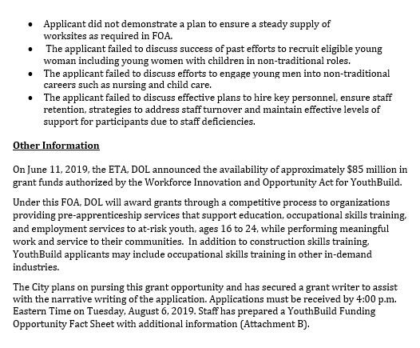
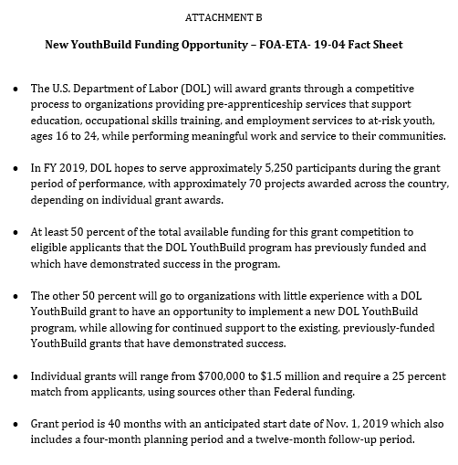
14. Matters for Future Discussion
None

15. Call to The Public
Elizabeth Cole, from Rio Salado Community College (RSC), who represents Title II programs, recognized PBWD Board Member Jesus Love, who is our Title II representative, for the work he has done with RSC.

15. Adjournment
A motion to adjourn the meeting was made at 10:35 a.m. by PBWD Board Member Jan Davis seconded by PBWD Board Member Travis Hardin.

All were in favor and the meeting adjourned.

