Phoenix Business and Workforce Development Board
Program Excellence Committee
Meeting Minutes

Virtual Meeting
March 4, 2021
9:00 a.m.

Members Present
Daniel Barajas, Vice Chair
Erick Garcia, Vice Chair
Edward Abramowitz
Michelle Jameson
Melissa Trujillo
Samantha Hansen
Stacie Garlieb

City of Phoenix Staff
LaSetta Hogans Ricardo Duran
Kimberly Whetstone Demitria Robles
Kweilin Waller Laura Whitehead
Christina Edwards

- Call to Order / Roll Call
Daniel Barajas, Program Excellence Committee (PEC) Vice Chair, called the March 4, 2021 meeting to order at 9:00 a.m. Roll call was completed, and a quorum was present.

- Approval of February 4, 2021 Meeting Minutes:
A motion to approve the February 4, 2021 Meeting Minutes, was made by PEC Member Michelle Jameson, and seconded by PEC Member, Erick Garcia.

Approved: Daniel Barajas, Erick Garcia, Edward Abramowitz, Michelle Jameson, Melissa Trujillo, Samantha Hansen and Stacie Garlieb.

Opposed: None

Motion passed unanimously
- Introduce New Committee Member:
PEC Vice Chair, Daniel Barajas, welcomed new committee member, Dean Van Kirk, to the PEC. Dean is an existing PBWD Board member who was reassigned to the PEC recently.

- Executive Leadership Committee (ELC) Report:
PEC Vice Chair, Erick Garcia, shared a brief recap of the recent PBWDB Executive Leadership Committee (ELC).
- Ricky Duran, City of Phoenix, Business and Workforce Division, Data and Research Manager, shared his Capstone Project with the committee members. The project focuses aligning workforce development with the needs of the community.

- The One-Stop Operator gave an analysis and update on the Client Referral System.

- The Youth services RFP selection process detailed the procurement efforts utilized to obtain new youth contracted providers to provide workforce development services for the City.

- The Youth Contract Risk Assessment policy was reviewed with the ELC and approved to move forward to the full board for final approval.

- The ELC reviewed an application for a Business seat on the PBWD Board.

- Q2 Performance Update Presentation
City of Phoenix, Business and Workforce Development Division, Data and Research Manager, Ricky Duran, gave a presentation to the committee on the WIOA Adult, Dislocated Worker and Youth program performance for the second quarter of the program year.

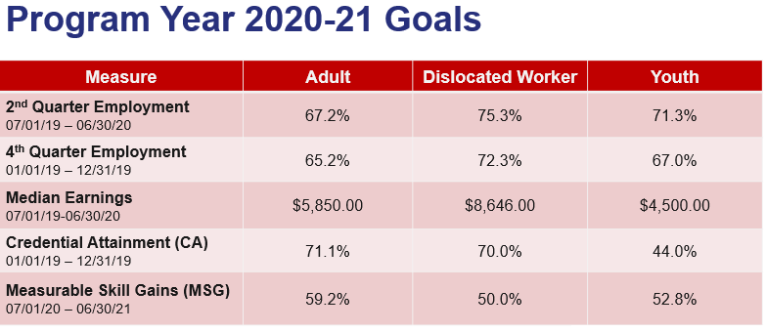
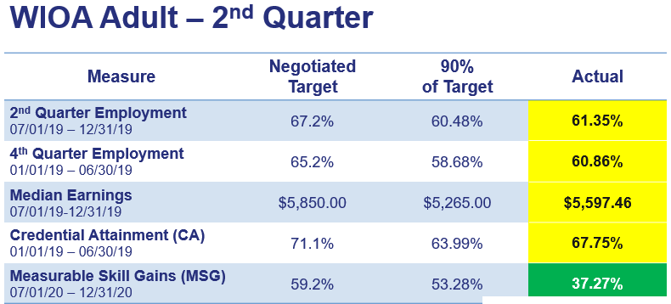

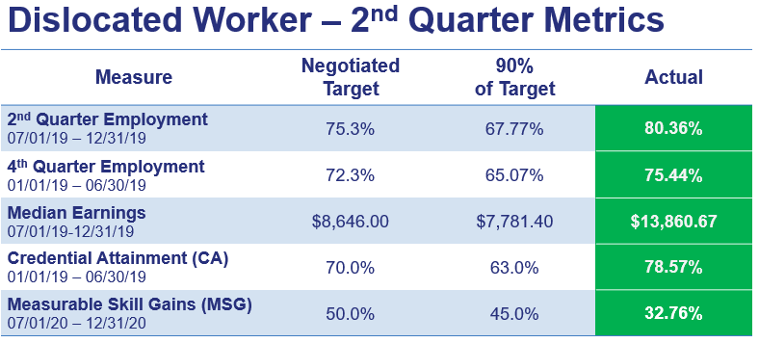

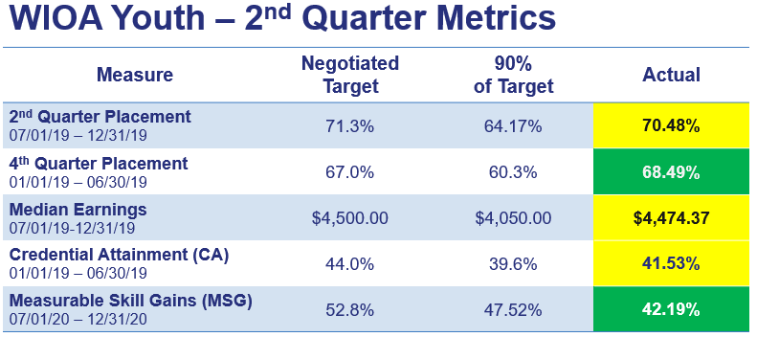

Ricky shared that the State’s case management system, Arizona Job Connection, has undergone a major update recently, which has caused some functionality associated with reporting to be affected.

Ricky will return to the PEC in the Summer to review the performance metrics for the third quarter of the program year.

- PEC Scorecard Review
PEC Vice Chair, Daniel Barajas, shared the actionable items on the scorecard are critical to implementing the Strategic Plan. The following suggestions to the scorecard were recommended:

GOAL 1: Instill Hope
Strategy 1: Develop opportunities for individual connections and relationships to support vulnerable populations including youth and dislocated workers.
Action Item # 1-
Research with Youth Providers about peer-to-peer mentor and support network, and support a formal youth mentorship program

Metric- Presentation to Board showing evidence of peer-to-peer mentor and support network and provide a summary of results with recommendations.
Action Item #2-
Capture success stories from partners and collaborate with the Board Committees to disseminate success stories to the community at large.

Metric- Every 1st week of every quarter, all Title programs will publish success stories to include testimonials and highlight experiences on twitter, Instagram and Facebook.
Action Item #3-
The workgroup recommends this Action Item be given to the Business and Workforce Engagement Committee and remove this strategy .

Action Item #4-
Explore supportive services approaches modeled by Marcos de Niza and Aeroterra staff and management with vulnerable populations

Metric- Summary Report of presentations to Board.
Action Item #5 –
Highlight new programs and exceptional outcomes about the Marcos de Niza, Aeroterra and other programs on the ARIZONA@WORK website, to educate all relevant partners and supporters.

Metric- Include link on website; present outcomes and share success stories to Board.

Action Item #6-
Stimulate services for youth at all locations

Metric – Research and provide an update to the board on the summary of services and best practices for youth programs and provide recommendations.

Action Item #7
Support dislocated workers to instill hope.

Metric – Research current practices and identify future opportunities that can be expanded to a variety of situations associated with layoffs and present findings and recommendations to the board

Action Item #8-
Explore and support an initiative to coordinate services to support the employment of those who may be close to eviction.

Metric- Research and identify current relevant partners; identify specific supportive services and provide suggestions to Board.

Action Item #9-
Research and support programs to activate financial self-sufficiency.

Metric- Identify programs for specific vulnerable populations; review success qualitatively, including testimonials.

PEC Member, Edward Abramowitz, asked if PBWDB Executive Director, LaSetta Hogans, and PEC Member, Melissa Trujillo, could meet offline to further discuss the intent and purpose of Strategy #3: Show promise for individuals seeking careers through the sharing of simple approaches.

A motion to approve the changes made to the PEC Scorecard , was made by PEC Member Michelle Jameson, and seconded by PEC Ad-Hoc Member, Samantha Hansen.

Approved: Daniel Barajas, Erick Garcia, Edward Abramowitz, Michelle Jameson, Melissa Trujillo, Samantha Hansen and Stacie Garlieb.

Opposed: None

Motion passed unanimously

- PEC Report Form:
PEC Vice Chair, Erick Garcia, recapped what will be included on the PEC report form that is sent monthly to the ELC and PBWD Board. PEC Member, Michelle Jameson, stated she wants to include social media success stories on the report. Also, Michelle would like the recommended scorecard changes included in the report.

PEC Vice Chair, Daniel Barajas, stated the committee will continue to work closely with Ricky Duran to ensure performance metrics are achieved.

- Matters for Future Discussion:

- Ricky Duran will provide more background information on how the Federal performance measures are calculated for the Adult, Dislocated Worker and Youth programs.

- The PEC would like to review the Communications Plan.

- PBWDB Executive Director, LaSetta Hogans, Erick Garcia, Edward Abramowitz and Melissa Trujillo will meet to discuss Strategy #3 – Career Pathways

- Call to the Public and Open Discussion:
None

- Adjournment:
A motion to adjourn the meeting was made at 10:25 a.m. by PEC Member Melissa Trujillo and seconded by PEC Member Michelle Jameson.

Approved: Daniel Barajas, Erick Garcia, Edward Abramowitz, Michelle Jameson, Melissa Trujillo, Samantha Hansen and Stacie Garlieb.

Opposed: None

Motion passed unanimously

